NAME________________________________________________ DATE_______________________ HOUR______
Unit 6- Geometry REVIEW
Question 1  Consider this figure.  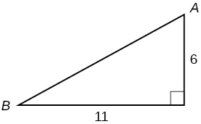  Enter the area of the right triangle, in square  centimeters.  square centimeters | Question 2  Ramon was plotting the coordinates of a polygon. He has plotted the coordinates of the polygon shown below. What is the area of Ramon's polygon?  1. Point A (2, 5)  2. Point B (8, 5)  3. Point C (8, 9)  4. Point D (5, 7)  5. Point E (2, 9)  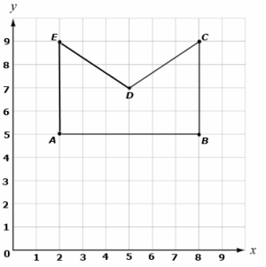  square units
Question 3  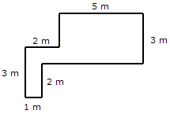  In the figure shown above, all the corners form right angles. What is the area of the figure?  - 8 m²  - 19 m²  - 16 m²  - 18 m² | Question 4  Use this figure to answer the questions that follow.  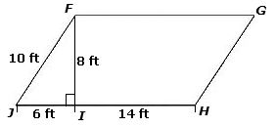  Part A:  What is the area of triangle FIJ?  Part B:  What is the area of parallelogram FGHJ?
Question 5  A cube has edges of 3 ½ inches. How many cubes with side lengths of ½ inches would be needed to fill the prism?  A 343 cubes  B 34.3 cubes  C 7 cubes  D 85.75 cubes | Question 6  A quadrilateral has the following vertices on a coordinate plane:  Point J: (3, –6)  Point K: (–1, –6)  Point L: (–1, 2)  Point M: (3, 2)  Enter the length of side KL.  units  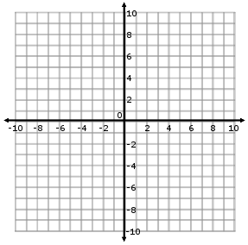
Question 7  Carterville was built along a grid using a coordinate plane. City Hall, the Fire Department, and the Police Department are the vertices of a triangle. City Hall is located at (1, 4), the Fire Department is located at (-3, 4) and the Police Department is located at (1, -2). Each square on the coordinate plane is equal to 1 square mile. Which department is closer to City Hall and by how much?  A The Fire Department is closer to City Hall by 4 miles.  B The Police Department is closer to City Hall by 6 miles.  C The Police Department is closer to City Hall by 2 miles.  D The Fire Department is closer to City Hall by 2 miles. | Question 8  Which of the following sets of coordinates represents the image shown below?  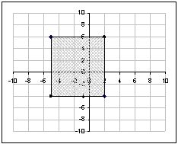  A (–5 , 6), (–5 , –4), (2 , 6), (2 , –4)  B (6 , –5), (–4 , 5), (6 , 2), (–4 , 2)  C (5 , –6), (5 , 4), (–2 , –6), (–2 , 4)  D (–6 , 5), (4 , 5), (–6 , –2), (4 , –2)
Question 9  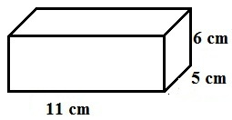  Calculate the volume of the rectangular prism in the diagram above.  A 330 cm³  B 302 cm³  C 22 cm³  D 130 cm³ | Question 10  Consider this figure.  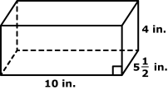  Enter the volume of this right rectangular prism in cubic inches.
Question 11  Philip claims this net will fold to form a triangular pyramid.  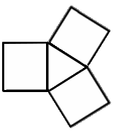  Is Philip correct?  A Yes.  B No, because a triangular pyramid does not have four faces.  C No, because all the faces of a triangular pyramid are triangles.  D No, because even though the net uses the correct type and number of shape, they are positioned incorrectly. | Question 12  What is the surface area of the net shown below?  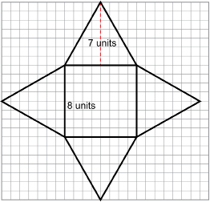
Question 13
What is the surface area of the box shown by the pattern below?
