Classwork
An activity will be completed in order to gain confidence in comparing rates on tables, graphs, and equations.

Exploratory Challenge
  - Mallory is on a budget and wants to determine which cereal is a better buy. A $10$-ounce box of cereal costs$\$2.79$, and a $13$-ounce box of the same cereal costs $\$3.99$.
    - Which box of cereal should Mallory buy?

    - What is the difference between the two unit prices?

  - Vivian wants to buy a watermelon. Kingston’s Market has $10$-pound watermelons for $\$3.90$, but the Farmer’s Market has $12$-pound watermelons for $\$4.44$.
    - Which market has the best price for watermelon?

    - What is the difference between the two unit prices?

  - Mitch needs to purchase soft drinks for a staff party. He is trying to figure out if it is cheaper to buy the $12$-pack of soda or the $20$-pack of soda. The $12$-pack of soda costs $\$3.99$, and the $20$-pack of soda costs $\$5.48$.
    - Which pack should Mitch choose?

    - What is the difference in cost between single cans of soda from each of the two packs?

  - Mr. Steiner needs to purchase $60$ AA batteries. A nearby store sells a $20$-pack of AA batteries for $\$12.49$ and a $12$-pack of the same batteries for $\$7.20$.
    - Would it be less expensive for Mr. Steiner to purchase the batteries in $20$-packs or $12$-packs?

    - What is the difference between the costs of one battery from each pack?

  - The table below shows the amount of calories Mike burns as he runs.
Number of Miles Ran | $$3$$ | $$6$$ | $$9$$ | $$12$$
Number of Calories Burned | $$360$$ | $$720$$ |  | $$1,440$$

Fill in the missing part of the table.

  - Emilio wants to buy a new motorcycle. He wants to compare the gas efficiency for each motorcycle before he makes a purchase. The dealerships presented the data below.

Sports Motorcycle: | Leisure Motorcycle:
Number of Gallons of Gas $$5$$ $$10$$ $$15$$ $$20$$  Number of Miles $$287.5$$ $$575$$ $$862.5$$ $$1,150$$ | 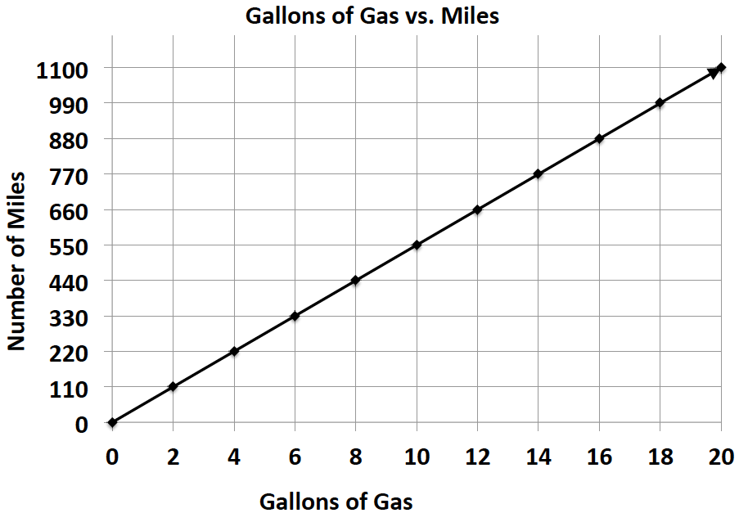

Which motorcycle is more gas efficient and by how much?

  - Milton Middle School is planning to purchase a new copy machine. The principal has narrowed the choice to two models: SuperFast Deluxe and Quick Copies. He plans to purchase the machine that copies at the fastest rate. Use the information below to determine which copier the principal should choose.

SuperFast Deluxe: | Quick Copies:
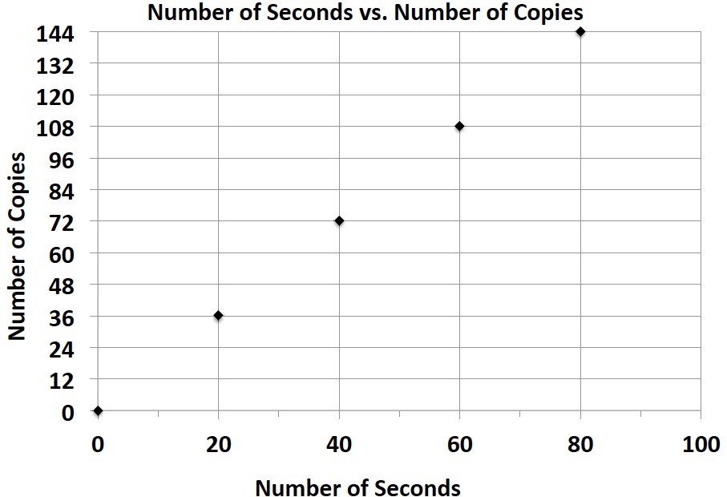 | $$c=1.5t$$  (where $t$ represents the amount of time in seconds, and $c$ represents the number of copies)

  - Elijah and Sean are participating in a walk-a-thon. Each student wants to calculate how much money he would make from his sponsors at different points of the walk-a-thon. Use the information in the tables below to determine which student would earn more money if they both walked the same distance. How much more money would that student earn per mile?

Elijah’s Sponsor Plan:
Number of Miles Walked | $$7$$ | $$14$$ | $$21$$ | $$28$$
Money Earned in Dollars | $$35$$ | $$70$$ | $$105$$ | $$140$$

Sean’s Sponsor Plan:
Number of Miles Walked | $$6$$ | $$12$$ | $$18$$ | $$24$$
Money Earned in Dollars | $$33$$ | $$66$$ | $$99$$ | $$132$$

  - Gerson is going to buy a new computer to use for his new job and also to download movies. He has to decide between two different computers. How many more kilobytes does the faster computer download in one second?
Choice 1: The rate of download is represented by the following equation: $k=153t$, where $t$ represents the amount of time in seconds, and $k$ represents the number of kilobytes.
Choice 2: The rate of download is represented by the following equation: $k=150t$, where $t$ represents the amount of time in seconds, and $k$ represents the number of kilobytes.

  - Zyearaye is trying to decide which security system company he will make more money working for. Use the graphs below that show Zyearaye’s potential commission rate to determine which company will pay Zyearaye more commission. How much more commission would Zyearaye earn by choosing the company with the better rate?

Superior Security: | Top Notch Security:
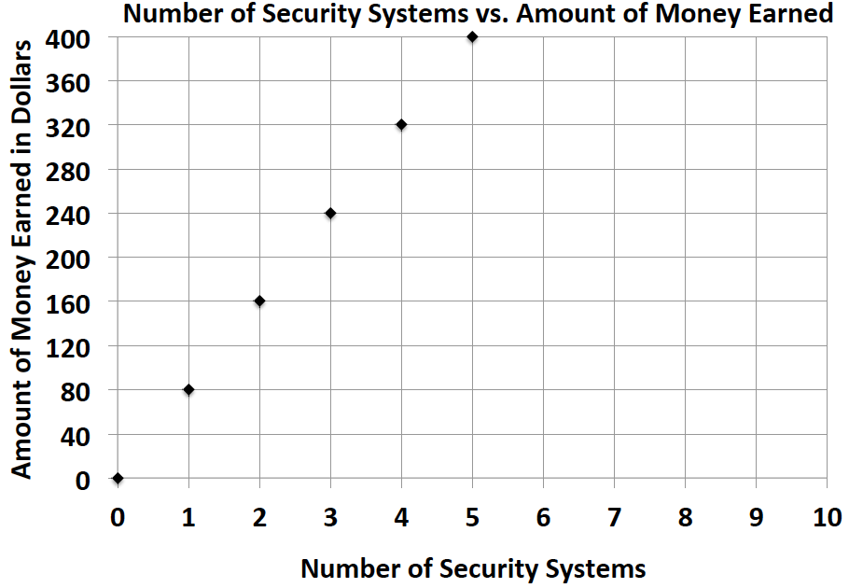 | 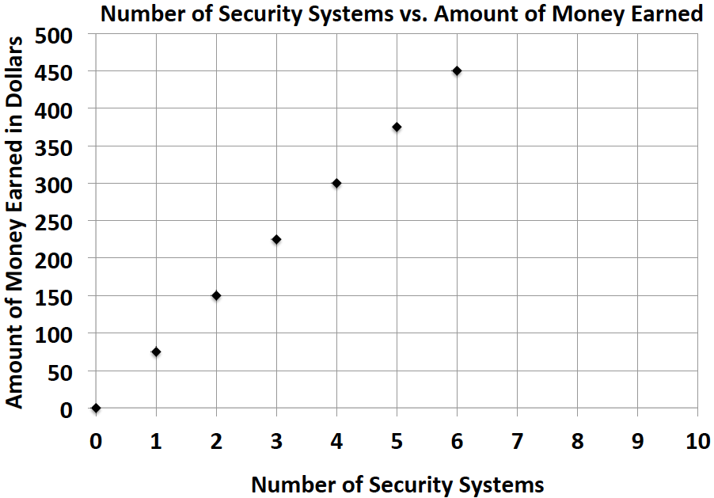

  - Emilia and Miranda are sisters, and their mother just signed them up for a new cell phone plan because they send too many text messages. Using the information below, determine which sister sends the most text messages. How many more text messages does this sister send per week?

Emilia:
Number of Weeks | $$3$$ | $$6$$ | $$9$$ | $$12$$
Number of Text Messages | $$1,200$$ | $$2,400$$ | $$3,600$$ | $$4,800$$

Miranda: $m=410w$, where $w$ represents the number of weeks, and $m$ represents the number of text messages.

Problem Set
Lesson Summary
Unit Rate can be located in tables, graphs, and equations.
- Table–the unit rate is the value of the first quantity when the second quantity is $1$.
- Graphs–the unit rate is the value of $r$ at the point $(1, r)$.
- Equation–the unit rate is the constant number in the equation. For example, the unit rate in $r=3b$ is $3$.

The table below shows the amount of money Gabe earns working at a coffee shop.
Number of Hours Worked | $$3$$ | $$6$$ | $$9$$ | $$12$$
Money Earned (in dollars) | $$40.50$$ | $$81.00$$ | $$121.50$$ | $$162.00$$

- How much does Gabe earn per hour?

- Jordan is another employee at the same coffee shop. He has worked there longer than Gabe and earns $\$3$ more per hour than Gabe. Complete the table below to show how much Jordan earns.
Number of Hours Worked | $$4$$ | $$8$$ | $$12$$ | $$16$$
Money Earned (in dollars)

- Serena is the manager of the coffee shop. The amount of money she earns is represented by the equation
$m=21h$, where $h$ is the number of hours Serena works, and $m$ is the amount of money she earns. How much more money does Serena make an hour than Gabe? Explain your thinking.

- Last month, Jordan received a promotion and became a manager. He now earns the same amount as Serena. How much more money does he earn per hour now that he is a manager than he did before his promotion? Explain your thinking.

