Classwork

Kelli is traveling by train with her soccer team from Yonkers, NY to Morgantown, WV for a tournament. The distance between Yonkers and Morgantown is $400$ miles. The total trip will take $8$ hours. The train schedule is provided below:
Leaving Yonkers, New York
Destination | Distance
Allentown, PA | $100$ miles
Carlisle, PA | $200$ miles
Berkeley Springs, WV | $300$ miles
Morgantown, WV | $400$ miles
Leaving Morgantown, WV
Destination | Distance
Berkeley Springs, WV | $100$ miles
Carlisle, PA | $200$ miles
Allentown, PA | $300$ miles
Yonkers, NY | $400$ miles
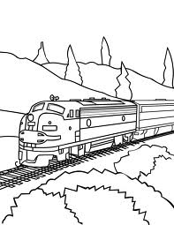
Exercises
- Create a table to show the time it will take Kelli and her team to travel from Yonkers to each town listed in the schedule assuming that the ratio of the amount of time traveled to the distance traveled is the same for each city. Then, extend the table to include the cumulative time it will take to reach each destination on the ride home.
Hours | Miles

- Create a double number line diagram to show the time it will take Kelli and her team to travel from Yonkers to each town listed in the schedule. Then, extend the double number line diagram to include the cumulative time it will take to reach each destination on the ride home. Represent the ratio of the distance traveled on the round trip to the amount of time taken with an equation.

Using the information from the double number line diagram, how many miles would be traveled in one hour?
________

How do you know? ______________________________________________________________________________________________
______________________________________________________________________________________________

Example 1
Dinner service starts once the train is $250$miles away from Yonkers. What is the minimum time the players will have to wait before they can have their meal?
Hours | Miles | Ordered Pairs

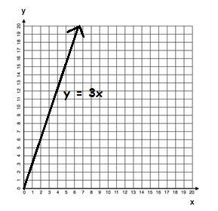
Ordered Pairs
$$(x, y)$$
$$(0, 0)$$
$$(1, 3)$$
$$(2, 6)$$
$$(3, 9)$$

Lesson Summary
A ratio table, equation, or double number line diagram can be used to create ordered pairs. These ordered pairs can then be graphed on a coordinate plane as a representation of the ratio.
Example:
Equation: $y=3x$

$$x$$ | $$y$$
$$0$$ | $$0$$
$$1$$ | $$3$$
$$2$$ | $$6$$
$$3$$ | $$9$$

Problem Set/Homework

- Complete the table of values to find the following:
Find the number of cups of sugar needed if for each pie Karrie makes, she has to use $3$ cups of sugar.
Pies | Cups of Sugar
$$1$$
$$2$$
$$3$$
$$4$$
$$5$$
$$6$$

Use a graph to represent the relationship.

Create a double number line diagram to show the relationship.

- Write a story context that would be represented by the ratio$1:4$.
Complete a table of values for this equation and graph.

