Classwork
Exploratory Challenge
Imagine that you are making a fruit salad. For every quart of blueberries you add, you would like to put in $3$ quarts of strawberries. Create three ratio tables that show the amounts of blueberries and strawberries you would use if you needed to make fruit salad for greater numbers of people.
Table 1 should contain amounts where you have added fewer than $10$ quarts of blueberries to the salad.
Table 2 should contain amounts of blueberries between and including $10$ and $50$ quarts.
Table 3 should contain amounts of blueberries greater than or equal to $100$ quarts.
Table 2
Quarts of Blueberries | Quarts of Strawberries

Table 1
Quarts of Blueberries | Quarts of Strawberries

Table 3
Quarts of Blueberries | Quarts of Strawberries

  - Describe any patterns you see in the tables. Be specific in your descriptions.

  - How are the amounts of blueberries and strawberries related to each other?

  - How are the values in the Blueberries column related to each other?

  - How are the values in the Strawberries column related to each other?

  - If we know we want to add $7$ quarts of blueberries to the fruit salad in Table 1, how can we use the table to help us determine how many strawberries to add?

  - If we know we used $70$ quarts of blueberries to make our salad, how can we use a ratio table to find out how many quarts of strawberries were used?

Exercise 1
The following tables were made incorrectly. Find the mistakes that were made, create the correct ratio table, and state the ratio that was used to make the correct ratio table.

Hours | Pay in Dollars |  | Hours | Pay in Dollars
$$3$$ | $$24$$
$$5$$ | $$40$$
$$7$$ | $$52$$
$$9$$ | $$72$$

Ratio _________________________

Blue | Yellow |  | Blue | Yellow
$$1$$ | $$5$$
$$4$$ | $$8$$
$$7$$ | $$13$$
$$10$$ | $$16$$

Ratio _________________________
Lesson Summary
Ratio tables are constructed in a special way.
Each pair of values in the table will be equivalent to the same ratio.
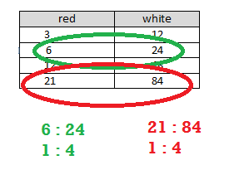
Repeated addition or multiplication can be used to create a ratio table.
The values in the first column can be multiplied by a constant value to get the values in the second column.
red | white
$$3 ×4$$ | $$12$$
$$6 ×4$$ | $$24$$
$$12 ×4$$ | $$48$$
$$21 ×4$$ | $$84$$
By just adding a certain number to the first entry of a ratio in the first column and adding the same number to the second entry in the second column, the new ratio formed is generally not equivalent to the original ratio. Instead, the numbers added to the entries must be related to the ratio used to make the table. However, if the entries in one column are multiplied by a certain number, multiplying the entries in the other column by the same number creates equivalent ratios.
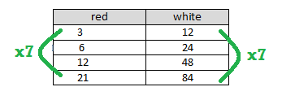

Problem Set

  - Create a ratio table for making lemonade with a lemon juice-to-water ratio of $1:3$. Show how much lemon juice would be needed if you use $36$ cups of water to make lemonade.

  - How is the value of the ratio used to create the table?

- Ryan made a table to show how much blue and red paint he mixed to get the shade of purple he will use to paint the room. He wants to use the table to make larger and smaller batches of purple paint.
Blue | Red
$$12$$ | $$3$$
$$20$$ | $$5$$
$$28$$ | $$7$$
$$36$$ | $$9$$
  - What ratio was used to create this table? Support your answer.

  - How are the values in each row related to each other?

  - How are the values in each column related to each other?

