Name ________________________
6th Grade Math- C. Rayman
Unit 5: Univariate Data
Hour ___________
Table: U of M MSU CMU WMU KC EMU KVCC

Lesson 9: The Mean Absolute Deviation (MAD)
Problem Set

- Suppose the dot plot on the left shows the number of goals a boys’ soccer team has scored in six games so far this season, and the dot plot on the right shows the number of goals a girls’ soccer team has scored in six games so far this season. The mean for both of these teams is $3$.
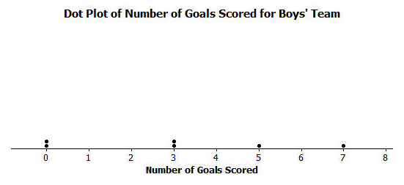

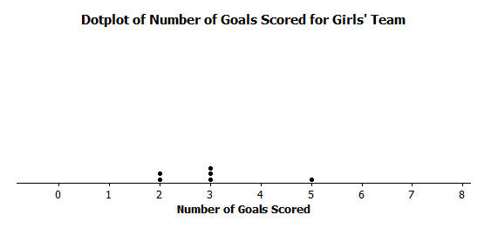

  - Before doing any calculations, which dot plot has the larger MAD? Explain how you know.

  - Use the following tables to find the MAD number of goals for each distribution. Round your calculations to the nearest hundredth.
Boys’ Team  #Goals Deviations Absolute Deviations  $$0$$ $$-3$$  $$0$$ $$-3$$  $$3$$ $$3-3=0$$  $$3$$  $$5$$  $$7$$  Sum | Girls’ Team  #Goals Deviations Absolute Deviations  $$2$$  $$2$$  $$3$$  $$3$$  $$3$$  $$5$$  Sum

  - Based on the computed MAD values, for which distribution is the mean a better indication of a typical value? Explain your answer.

- Recall Robert’s problem of deciding whether to move to New York City or to San Francisco. The table of temperatures (in degrees Fahrenheit) and deviations for the New York City distribution is as follows:
NYC | Jan | Feb | Mar | Apr | May | Jun | Jul | Aug | Sep | Oct | Nov | Dec
Temp | $$39$$ | $$42$$ | $$50$$ | $$61$$ | $$71$$ | $$81$$ | $$85$$ | $$84$$ | $$76$$ | $$65$$ | $$55$$ | $$47$$
Deviation | $$-24$$ | $$-21$$ | $$-13$$ | $$-2$$ | $$8$$ | $$18$$ | $$22$$ | $$21$$ | $$13$$ | $$2$$ | $$-8$$ | $$-16$$
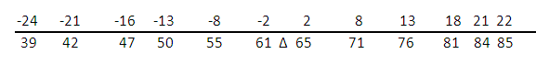
  - The dot plot below is written with the deviations above each of the monthly temperatures. What is the sum of all of the deviations? Are you surprised? Explain.

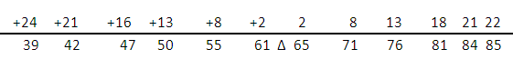
  - The absolute deviations for the monthly temperatures are shown below. Use this information to calculate the MAD. Explain the MAD in words for this problem.

  - Complete the following table and then use the values to calculate the MAD for the San Francisco data distribution.
Month | Jan | Feb | Mar | Apr | May | Jun | Jul | Aug | Sep | Oct | Nov | Dec
Temp | $$57$$ | $$60$$ | $$62$$ | $$63$$ | $$64$$ | $$67$$ | $$67$$ | $$68$$ | $$70$$ | $$69$$ | $$63$$ | $$58$$
Deviations |  |  |  | $$-1$$ | $$0$$ | $$+3$$
Absolute Deviations
  - Comparing the MAD values for New York City and San Francisco, which city would Robert choose to move to if he is interested in having a lot of variability in monthly temperatures? Explain using the MAD.

- Consider the following data of the number of green jellybeans in seven bags sampled from five different candy manufacturers (Awesome, Delight, Finest, Sweeties, YumYum). Note that the mean in each distribution is $42$ green jellybeans.
 | Bag $1$ | Bag $2$ | Bag $3$ | Bag $4$ | Bag $5$ | Bag $6$ | Bag $7$
Awesome | $$40$$ | $$40$$ | $$41$$ | $$42$$ | $$42$$ | $$43$$ | $$46$$
Delight | $$22$$ | $$31$$ | $$36$$ | $$42$$ | $$48$$ | $$53$$ | $$62$$
Finest | $$26$$ | $$36$$ | $$40$$ | $$43$$ | $$47$$ | $$50$$ | $$52$$
Sweeties | $$36$$ | $$39$$ | $$42$$ | $$42$$ | $$42$$ | $$44$$ | $$49$$
YumYum | $$33$$ | $$36$$ | $$42$$ | $$42$$ | $$45$$ | $$48$$ | $$48$$

  - Complete the following table of the deviations of the number of green jellybeans from the mean number of green jellybeans in the seven bags.
 | Bag $1$ | Bag $2$ | Bag $3$ | Bag $4$ | Bag $5$ | Bag $6$ | Bag $7$
Awesome | $$-2$$ | $$-2$$ | $$-1$$ | $$0$$ | $$0$$ | $$+1$$ | $$+4$$
Delight | $$-20$$ | $$-11$$ | $$-6$$
Finest | $$-16$$
Sweeties
YumYum

  - Based on what you learned about MAD, which manufacturer do you think will have the lowest MAD? Calculate the MAD for the manufacturer you selected.

