Name ________________________
6th Grade Math- C. Rayman
Unit 5: Univariate Data
Hour ___________
Table: U of M MSU CMU WMU KC EMU KVCC

Lesson 7: The Mean as a Balance Point

Problem Set

- The number of pockets in the clothes worn by four students to school today is $4$, $1$, $3$, $4$.
  - Perform the “fair share” process to find the mean number of pockets for these four students. Sketch the cube representations for each step of the process.
  - Find the sum of the deviations to prove the mean found in part (a) is correct.

- The times (rounded to the nearest minute) it took each of six classmates to run a mile are $7$, $9$, $10$, $11$, $11$, and $12$ minutes.
  - Draw a dot plot representation for the times. Suppose that Sabina thinks the mean is $11$ minutes. Use the sum of the deviations to show Sabina that the balance point of $11$ is too high.
  - Sabina now thinks the mean is $9$ minutes. Use the sum of the deviations to verify that $9$ is too small to be the mean number of pockets.
  - Sabina asks you to find the mean by using the balancing process. Demonstrate that the mean is $10$ minutes.

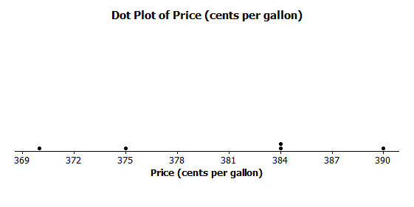
- The prices per gallon of gasoline (in cents) at five stations across town on one day are shown in the following dot plot. The price for a sixth station is missing, but the mean price for all six stations was reported to be $380$ cents per gallon. Use the “balancing” process to determine the price of a gallon of gasoline at the sixth station?

- The number of phones (landline and cell) owned by the members of each of nine families is $3$, $5$,$5$,$5$, $6$, $6$, $6$,$6$,$8.$
  - Use the mathematical formula for the mean (sum the data points and divide by the number of data points) to find the mean number of phones owned for these nine families.
  - Draw a dot plot of the data and verify your answer in part (a) by using the “balancing” process and finding the sum of the deviations.

