Lesson 9: Determining Perimeter and Area of Polygons on the Coordinate Plane

Problem Set

- Determine the area of the polygon.
y
x
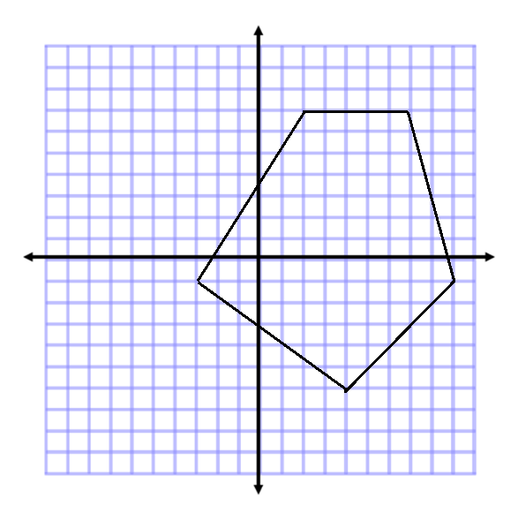

- Determine the area and perimeter of the polygon.
y
x
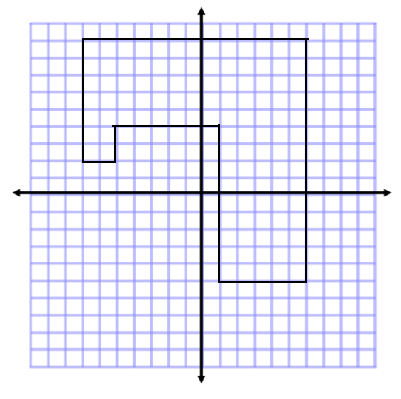

- Determine the area of the polygon. Then, write an expression that could be used to determine the area.
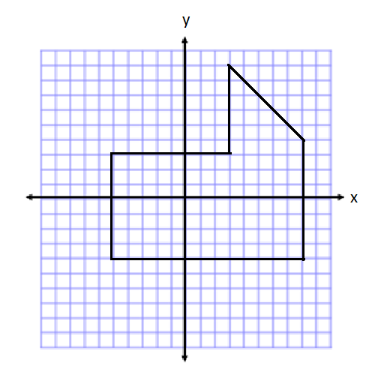

- If the length of each square was worth $2$ instead of $1$, how would the area in Problem 3 change? How would your expression change to represent this area?

- Determine the area of the polygon. Then, write an expression that represents the area.
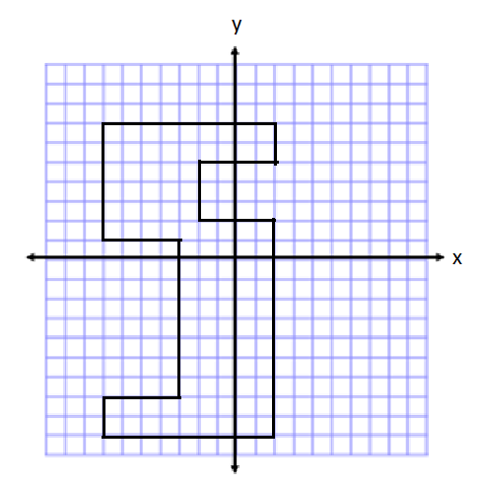

- Describe another method you could use to find the area of the polygon in Problem 5. Then, state how the expression for the area would be different than the expression you wrote.

- Write one of the letters from your name using rectangles on the coordinate plane. Then, determine the area and perimeter. (For help see Exercise 2(b). This irregular polygon looks sort of like a T.)
y
x

