Lesson 7: Distance on the Coordinate Plane

Problem Set

- Given the pairs of points, determine whether the segment that joins them is horizontal, vertical, or neither.
  - $X(3, 5)$and$Y(-2, 5)$
  - $M(-4, 9)$ and$N(4, -9)$
  - $E(-7, 1)$and$F(-7, 4)$

- Complete the table using absolute value to determine the lengths of the line segments.
Line Segment | Point | Point | Distance | Proof
$$\overline{AB}$$ | $$(-3, 5)$$ | $$(7, 5)$$
$$\overline{CD}$$ | $$(1, -3)$$ | $$(-6, -3)$$
$$\overline{EF}$$ | $$(2, -9)$$ | $$(2, -3)$$
$$\overline{GH}$$ | $$(6, 1)$$ | $$(6, 16)$$
$$\overline{JK}$$ | $$(-3, 0)$$ | $$(-3, 12)$$

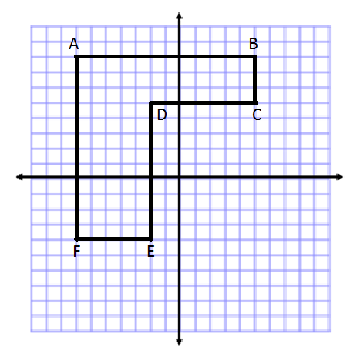
- Complete the table using the diagram and absolute value to determine the lengths of the line segments.
$$y$$
$$x$$
Line Segment | Point | Point | Distance | Proof
$$\overline{AB}$$
$$\overline{BC}$$
$$\overline{CD}$$
$$\overline{DE}$$
$$\overline{EF}$$
$$\overline{FA}$$

Line Segment | Point | Point | Distance | Proof
$$\overline{AB}$$
$$\overline{CG}$$
$$\overline{CF}$$
$$\overline{GF}$$
$$\overline{DH}$$
$$\overline{DE}$$
$$\overline{HJ}$$
$$\overline{KL}$$
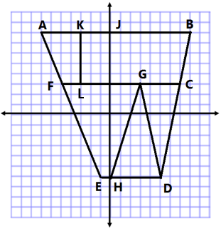
- Complete the table using the diagram and absolute value to determine the lengths of the line segments.
$$y$$
$$x$$

- Name two points in different quadrants that form a vertical line segment that is $8$ units in length.

- Name two points in the same quadrant that form a horizontal line segment that is $5$ units in length.

