Lesson 5: The Area of Polygons through Composition and Decomposition

Problem Set
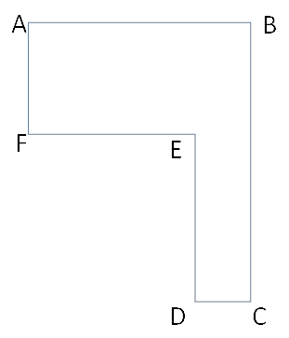
- If $AB=20 units$, $FE=12 units$, $AF=9 units$, and $DE=12 units$, find the length of the other two sides. Then, find the area of the irregular polygon.

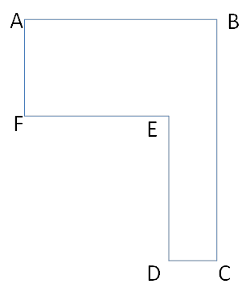
- If $DC=1.9 cm$, $FE=5.6 cm$, $AF=4.8 cm$, and $BC=10.9 cm$, find the length of the other two sides. Then, find the area of the irregular polygon.

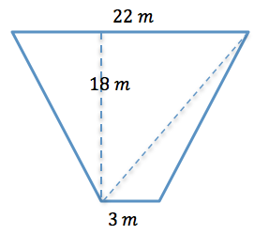

- Determine the area of the trapezoid. The trapezoid is not drawn to scale.

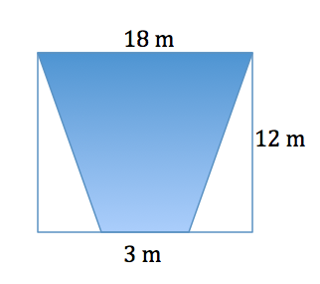
- Determine the area of the shaded isosceles trapezoid. The image is not drawn to scale.

- Here is a sketch of a wall that needs to be painted:
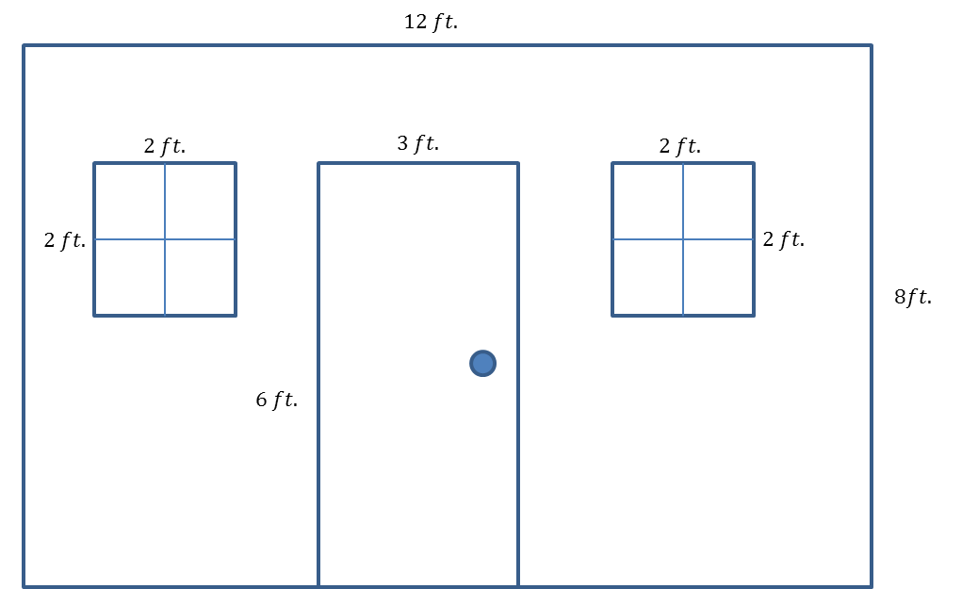

- The windows and door will not be painted. Calculate the area of the wall that will be painted.

- If a quart of Extra-Thick Gooey Sparkle paint covers$30 {ft}^{2}$, how many quarts must be purchased for the painting job?

- The figure below shows a floor plan of a new apartment. New carpeting has been ordered, which will cover the living room and bedroom but not the kitchen or bathroom. Determine the carpeted area by composing or decomposing in two different ways, and then explain why they are equivalent.
