Lesson 4: The Area of All Triangles Using Height and Base

Problem Set

Calculate the area of each figure below. Figures are not drawn to scale.
- 2.
$$21 m$$
$$72 m$$
$$75 m$$
$$10 in.$$
$$8 in.$$
$$17 in.$$
$$15 in.$$
$$6 in.$$

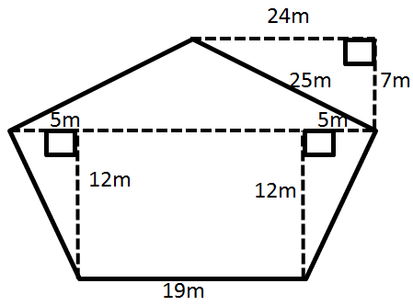
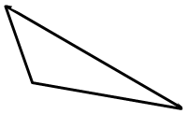
$$21.9 km$$

$$75.8 km$$
$$29.2 km$$
- 4.

- The Andersons are going on a long sailing trip during the summer. However, one of the sails on their sailboat ripped, and they have to replace it. The sail is pictured below.
If the sailboat sails are on sale for $\$2$ per square foot, how much will the new sail cost?
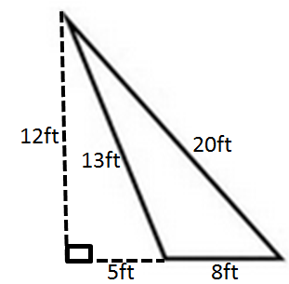

- Darnell and Donovan are both trying to calculate the area of an obtuse triangle. Examine their calculations below.
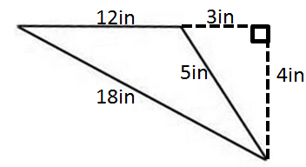

Darnell’s Work | Donovan’s Work
$$A=\frac{1}{2}×3 in\text{.}×4 in. \\ A=6 in^{2}$$ | $$A=\frac{1}{2}×12 in\text{.}×4 in. \\ A=24 in^{2}$$
Which student calculated the area correctly? Explain why the other student is not correct.

- Russell calculated the area of the triangle below. His work is shown.
$$25 cm$$
xxxx
$$7 cm$$
$$24 cm$$
$$25 cm$$
$$43 cm$$
$$A=\frac{1}{2}×43 cm×7 cm \\ A=150.5 {cm}^{2}$$
Although Russell was told his work is correct, he had a hard time explaining why it is correct. Help Russell explain why his calculations are correct.

- The larger triangle below has a base of $10.14 m$; the gray triangle has an area of $40.325 m^{2}$.
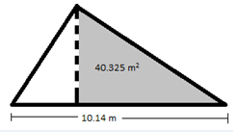

  - Determine the area of the larger triangle if it has a height of $12.2 m$.
  - Let $A$ be the area of the unshaded (white) triangle in square meters. Write and solve an equation to determine the value of $A$, using the areas of the larger triangle and the gray triangle.

