Lesson 3: The Area of Acute Triangles Using Height and Base
Problem Set
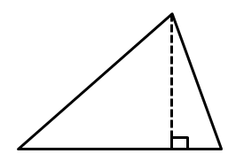
Calculate the area of each shape below. Figures are not drawn to scale.
$$8 m$$
$$14 m$$
$$16 m$$

- 2.
$$4.4 in.$$
$$3.3 in.$$
$$6.1 in.$$
$$5.5 in.$$

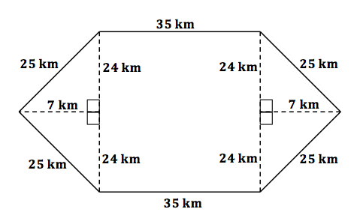
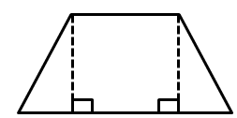
- 4.
$$5 ft.$$
$$12 ft.$$
$13$ ft.
$$13 ft.$$
$12$ ft.
$$12 ft.$$
$$5 ft.$$

5. Immanuel is building a fence to make an enclosed play area for his dog. The enclosed area will be in the shape of a triangle with a base of $48 m.$ and an altitude of $32 m$. How much space does the dog have to play?

6. Chauncey is building a storage bench for his son’s playroom. The storage bench will fit into the corner and against two walls to form a triangle. Chauncey wants to buy a triangular shaped cover for the bench.
Note: Figure is not to scale.
If the storage bench is $2\frac{1}{2} ft.$ along one wall and $4\frac{1}{4} ft.$ along the other wall, how big will the cover have to be to cover the entire bench?
$5$ in.
$3$ in.
$4$ in.
$7$ in.
- Examine the triangle to the right.
  - Write an expression to show how you would calculate the area.
  - Identify each part of your expression as it relates to the triangle.

- The floor of a triangular room has an area of $32\frac{1}{2} sq. m.$ If the triangle’s altitude is $7\frac{1}{2} m$, write an equation to determine the length of the base, $b$, in meters. Then solve the equation.

