Lesson 2: The Area of Right Triangles

Problem Set

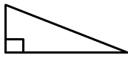
Calculate the area of each right triangle below. Note that the figures are not drawn to scale.
$$9.1 cm$$
$$31.2 cm$$
$$32.5 cm$$
- 2.
$$3\frac{3}{4} km$$
$$5 km$$
$$6\frac{1}{4} km$$

- 4.
$$4 in.$$
$$2.4 in.$$
$$3.2 in.$$
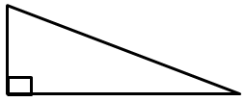
$$11 mm$$
$$60 mm$$
$$61 mm$$

$$16\frac{2}{3} ft.$$
$$10 ft.$$
$$13\frac{1}{3} ft.$$

- Elania has two congruent rugs at her house. She cut one vertically down the middle, and she cut diagonally through the other one.

A
B
C
D

After making the cuts, which rug (labeled A, B, C, or D) has the larger area? Explain.

- Give the dimensions of a right triangle and a parallelogram with the same area. Explain how you know.

- If the area of a right triangle is $\frac{9}{16} sq. ft.$ and the height is $\frac{3}{4} ft.$, write an equation that relates the area to the base, $b$, and the height. Solve the equation to determine the base.

