Lesson 17: From Nets to Surface Area

Problem Set

Name the shape, and write an expression for surface area. Calculate the surface area of the figure. Assume each box on the grid paper represents a $1 ft\text{. }× 1 ft.$ square.
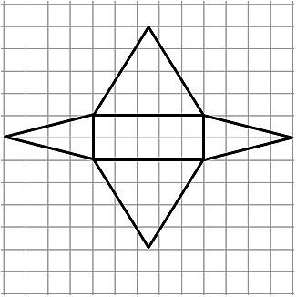

Explain the error in each problem below. Assume each box on the grid paper represents a $1 m × 1 m$ square.
Name of Shape: Rectangular Pyramid, but more specifically a Square Pyramid
Area of Base: $3 m × 3 m=9 m^{2}$
Area of Triangles: $3 m × 4 m=12 m^{2}$
Surface Area: $9 m^{2}+12 m^{2}+12 m^{2}+12 m^{2}+12 m^{2}=57 m^{2}$

 | 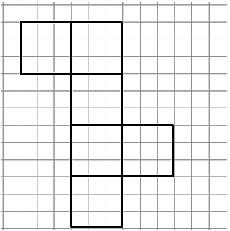 | Name of Shape: Rectangular Prism or, more specifically, a Cube  Area of Faces: $3 m × 3 m=9 m^{2}$  Surface Area: $9 m^{2}+9 m^{2}+9 m^{2}+9 m^{2}+9 m^{2}=45 m^{2}$

- Sofia and Ella are both writing expressions to calculate the surface area of a rectangular prism. However, they wrote different expressions.
  - Examine the expressions below, and determine if they represent the same value. Explain why or why not.

Sofia’s Expression:
$$\left(3 cm × 4 cm\right)+\left(3 cm × 4 cm\right)+\left(3 cm × 5 cm\right)+\left(3 cm × 5 cm\right)+\left(4 cm × 5 cm\right)+(4 cm × 5 cm)$$

Ella’s Expression:
$$2\left(3 cm × 4 cm\right)+2\left(3 cm × 5 cm\right)+2(4 cm × 5 cm)$$

  - What fact about the surface area of a rectangular prism does Ella’s expression show more clearly than Sofia’s?

