Lesson 14: Volume in the Real World

Problem Set

- The volume of a rectangular prism is $\frac{21}{12}{ ft}^{3}$, and the height of the prism is $\frac{3}{4} ft$. Determine the area of the base.

- The volume of a rectangular prism is $\frac{10}{21} {ft}^{3}$. The area of the base is $\frac{2}{3} {ft}^{2}$. Determine the height of the rectangular prism.

- Determine the volume of the space in the tank that still needs to be filled with water if the water is $\frac{1}{3} f$t. deep.
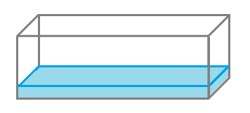
$$5 ft.$$
$$1\frac{2}{3} ft.$$
$$2 ft.$$

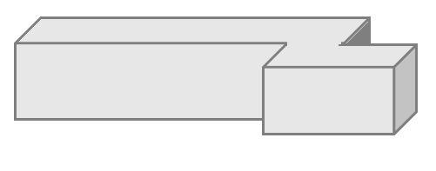
- Determine the volume of the composite figure.
$$\frac{3}{4} m$$
$$\frac{1}{8} m$$
$$\frac{1}{3} m$$
$$\frac{1}{4} m$$
$$\frac{1}{3} m$$

- Determine the volume of the composite figure.
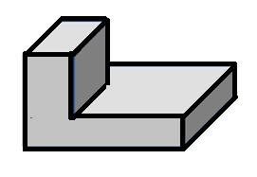
$$1 in.$$
$$3 in.$$
$$2\frac{1}{2} in.$$
$$\frac{1}{4} in.$$
$$1\frac{1}{2} in.$$
$$1\frac{1}{4}in.$$

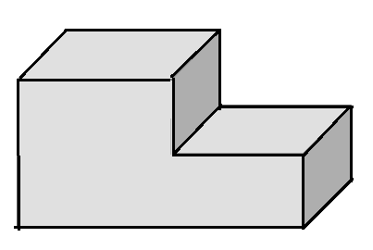
$$7\frac{1}{4} m$$
$$2 m$$
$$3\frac{1}{2} m$$
$$1\frac{1}{4} m$$
$$1 m$$

  - Write an equation to represent the volume of the composite figure.
  - Use your equation to calculate the volume of the composite figure.

