Lesson 10: Distance, Perimeter, and Area in the Real World
Problem Set
- How is the length of the side of a square related to its area and perimeter? The diagram below shows the first four squares stacked on top of each other with their upper left-hand corners lined up. The length of one side of the smallest square is $1$ foot.
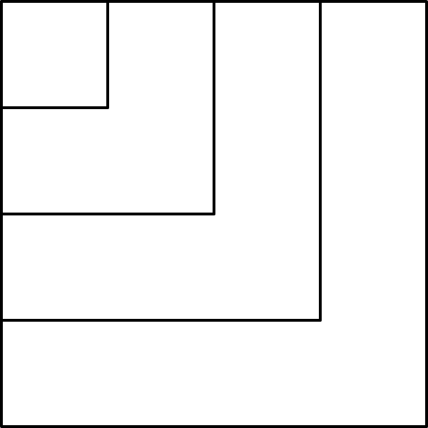

  - Complete this chart calculating area and perimeter for each square.
Side Length  (in feet) | Expression Showing the Area | Area  (in square feet) | Expression Showing the Perimeter | Perimeter  (in feet)
$$1$$ | $$1×1$$ | $$1$$ | $$1×4$$ | $$4$$
$$2$$
$$3$$
$$4$$
$$5$$
$$6$$
$$7$$
$$8$$
$$9$$
$$10$$
$$n$$
  - In a square, which numerical value is greater, the area or the perimeter?
  - When is the numerical value of a square’s area (in square units) equal to its perimeter (in units)?
  - Why is this true?
This drawing shows a school pool. The walkway around the pool needs special nonskid strips installed but only at the edge of the pool and the outer edges of the walkway.
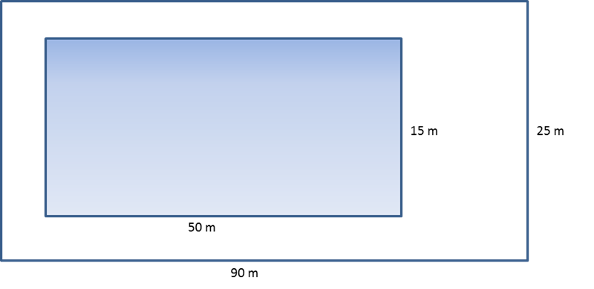
  - Find the length of nonskid strips that is needed for the job.
  - The nonskid strips are sold only in rolls of $50 m$. How many rolls need to be purchased for the job?

- A homeowner called in a painter to paint the walls and ceiling of one bedroom. His bedroom is $18 ft.$ long, $12 ft.$ wide, and $8 ft.$ high. The room has two doors, each $3 ft.$ by $7 ft.$, and three windows each $3 ft.$ by$5 ft$. The doors and windows will not be painted. A gallon of paint can cover$300 ft^{2}$. A hired painter claims he needs a minimum of $4$gallons. Show that his estimate is too high.

- Theresa won a gardening contest and was awarded a roll of deer-proof fencing. The fencing is $36$feet long. She and her husband, John, discuss how to best use the fencing to make a rectangular garden. They agree that they should only use whole numbers of feet for the length and width of the garden.
  - What are all of the possible dimensions of the garden?
  - Which plan yields the maximum area for the garden? Which plan yields the minimum area?

- Write and then solve the equation to find the missing value below.

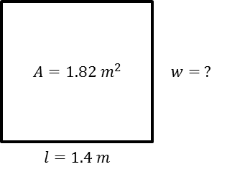

- Challenge: This is a drawing of the flag of the Republic of the Congo. The area of this flag is $3\frac{3}{4}{ft}^{2}$.
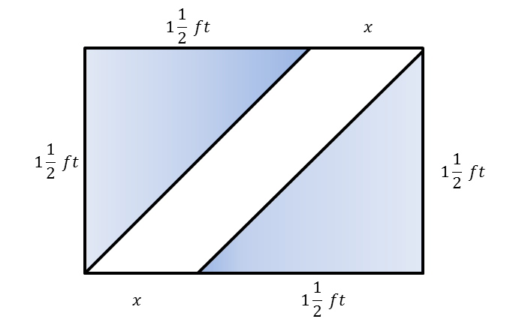
  - Using the area formula, tell how you would determine the value of the base. This figure is not drawn to scale.
  - Using what you found in part (a), determine the missing value of the base.

