Lesson 34: Writing and Graphing Inequalities in Real-World Problems

Problem Set

Write and graph an inequality for each problem.
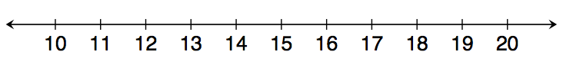
- At least $13$

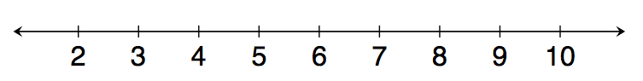
- Less than $7$

- Chad will need at least $24$ minutes to complete the $5$K race. However, he wants to finish in under $30$ minutes.
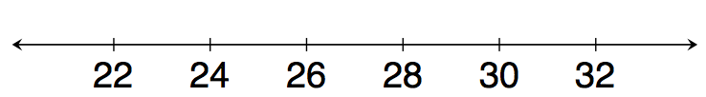

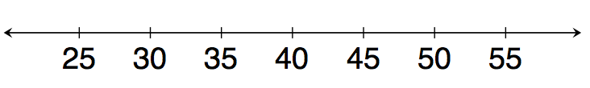
- Eva saves $\$60$ each week. Since she needs to save at least $\$2,400$ to go on a trip to Europe, she will need to save for at least $40$ weeks.

- Clara has $\$100$. She wants to buy $4$ pairs of the same pants. Due to tax, Clara can afford pants that are less than $\$25$.
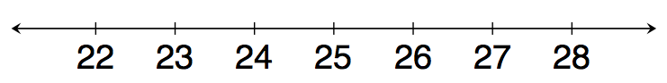

- A gym charges $\$30$ per month plus $\$4$ extra to swim in the pool for an hour. Because a member has just $\$50$ to spend at the gym each month, the member can swim at most $5$ hours.
