Lesson 22: Writing and Evaluating Expressions—Exponents
Problem Set
- A checkerboard has $64$ squares on it.
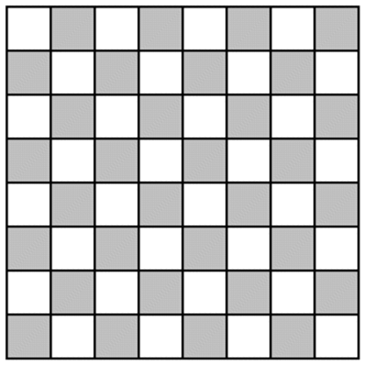
  - If one grain of rice is put on the first square, $2$ grains of rice on the second square, $4$ grains of rice on the third square, $8$ grains of rice on the fourth square, and so on (doubling each time), complete the table to show how many grains of rice are on each square. Write your answers in exponential form on the table below.
Checkerboard Square | Grains of Rice | Checkerboard Square | Grains of Rice | Checkerboard Square | Grains of Rice | Checkerboard Square | Grains of Rice
$$1$$ |  | $$17$$ |  | $$33$$ |  | $$49$$
$$2$$ |  | $$18$$ |  | $$34$$ |  | $$50$$
$$3$$ |  | $$19$$ |  | $$35$$ |  | $$51$$
$$4$$ |  | $$20$$ |  | $$36$$ |  | $$52$$
$$5$$ |  | $$21$$ |  | $$37$$ |  | $$53$$
$$6$$ |  | $$22$$ |  | $$38$$ |  | $$54$$
$$7$$ |  | $$23$$ |  | $$39$$ |  | $$55$$
$$8$$ |  | $$24$$ |  | $$40$$ |  | $$56$$
$$9$$ |  | $$25$$ |  | $$41$$ |  | $$57$$
$$10$$ |  | $$26$$ |  | $$42$$ |  | $$58$$
$$11$$ |  | $$27$$ |  | $$43$$ |  | $$59$$
$$12$$ |  | $$28$$ |  | $$44$$ |  | $$60$$
$$13$$ |  | $$29$$ |  | $$45$$ |  | $$61$$
$$14$$ |  | $$30$$ |  | $$46$$ |  | $$62$$
$$15$$ |  | $$31$$ |  | $$47$$ |  | $$63$$
$$16$$ |  | $$32$$ |  | $$48$$ |  | $$64$$
  - How many grains of rice would be on the last square? Represent your answer in exponential form and standard form. Use the table above to help solve the problem.
  - Would it have been easier to write your answer to part (b) in exponential form or standard form?
- If an amount of money is invested at an annual interest rate of $6\%$, it doubles every $12$ years. If Alejandra invests $\$500$, how long will it take for her investment to reach $\$2,000$ (assuming she does not contribute any additional funds)?

- The athletics director at Peter’s school has created a phone tree that is used to notify team players in the event a game has to be canceled or rescheduled. The phone tree is initiated when the director calls two captains. During the second stage of the phone tree, the captains each call two players. During the third stage of the phone tree, these players each call two other players. The phone tree continues until all players have been notified. If there are $50$ players on the teams, how many stages will it take to notify all of the players?

