Lesson 14: Writing Division Expressions

Problem Set

Complete the missing spaces in each rectangle set.
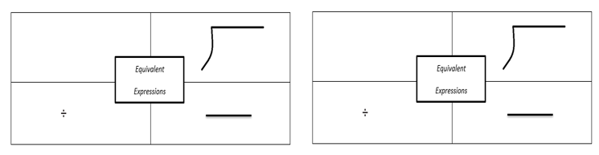
$$2$$
$$y+13$$
$7$ divided by $x$
$$b - 33$$
$$m$$
$h$ $16$

