Lesson 2: Real-World Positive and Negative Numbers and Zero

Problem Set

1. Express each situation as an integer in the space provided.

|  |  |
| --- | --- |
| * 1. A gain of points in a game |  |
| * 1. A fee charged of |  |
| * 1. A temperature of degrees below zero |  |
| * 1. A -yard loss in a football game |  |
| * 1. The freezing point of water in degrees Celsius |  |
| * 1. A deposit |  |

For Problems 2–5, use the thermometer to the right.

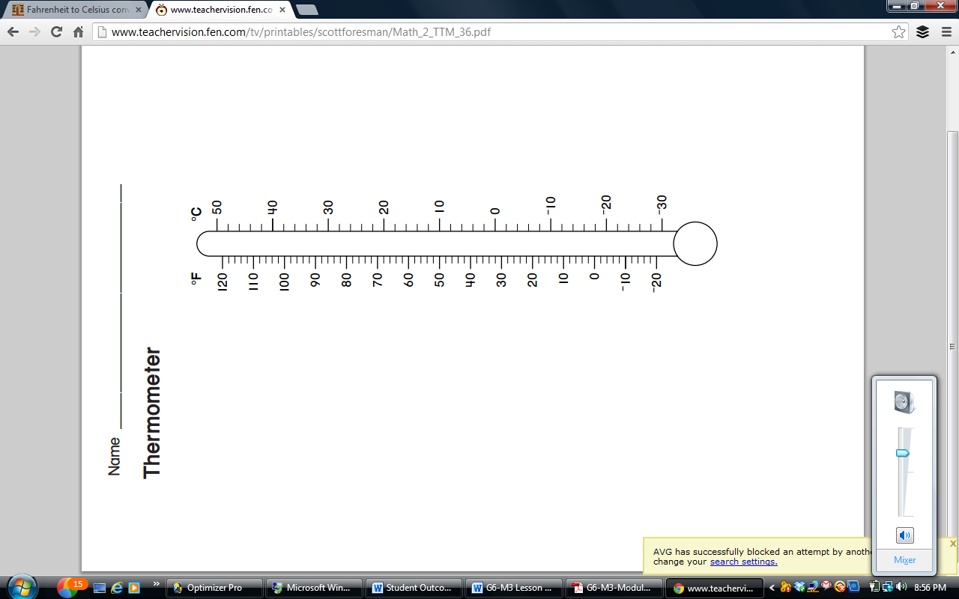

1. Each sentence is stated *incorrectly*. Rewrite the sentence to correctly describe each situation.
   1. The temperature is $-10$ degrees Fahrenheit below zero.
   2. The temperature is $-22$ degrees Celsius below zero.
2. Mark the integer on the thermometer that corresponds to the temperature given.
$70°F$

$12℃$

$110℉$

$-4℃$

3. The boiling point of water is $212°F$. Can this thermometer be used to record the temperature of a boiling pot of water? Explain.
4. Kaylon shaded the thermometer to represent a temperature of $20$ degrees below zero Celsius as shown in the diagram. Is she correct? Why or why not? If necessary, describe how you would fix Kaylon’s shading.