Lesson 16: Symmetry in the Coordinate Plane

Problem Set

- Locate a point in Quadrant IV of the coordinate plane. Label the point $A$, and write its ordered pair next to it.
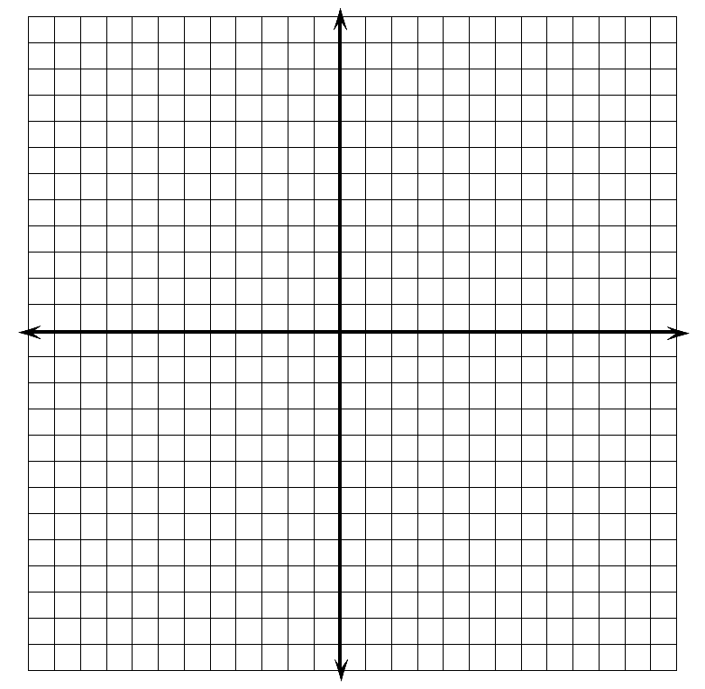
  - Reflect point $A$ over an axis so that its image is in Quadrant III. Label the image $B$, and write its ordered pair next to it. Which axis did you reflect over? What is the only difference in the ordered pairs of points $A$ and $B$?
  - Reflect point $B$ over an axis so that its image is in Quadrant II. Label the image $C$, and write its ordered pair next to it. Which axis did you reflect over? What is the only difference in the ordered pairs of points $B$ and $C$? How does the ordered pair of point $C$ relate to the ordered pair of point $A$?
  - Reflect point $C$ over an axis so that its image is in Quadrant I. Label the image $D$, and write its ordered pair next to it. Which axis did you reflect over? How does the ordered pair for point $D$ compare to the ordered pair for point $C$? How does the ordered pair for point $D$ compare to points $A$ and $B$?

- Bobbie listened to her teacher’s directions and navigated from the point $\left(-1, 0\right)$ to $\left(5,-3\right)$. She knows that she has the correct answer, but she forgot part of the teacher’s directions. Her teacher’s directions included the following:
“Move $7$ units down, reflect about the ? -axis, move up $4$ units, and then move right $4$ units.”
Help Bobbie determine the missing axis in the directions, and explain your answer.

