Lesson 15: Locating Ordered Pairs on the Coordinate Plane

Problem Set

- Name the quadrant in which each of the points lies. If the point does not lie in a quadrant, specify which axis the point lies on.
  - $\left(-2, 5\right)$
  - $\left(8,-4\right)$
  - $\left(-1,-8\right)$
  - $\left(9.2, 7\right)$
  - $\left(0,-4\right)$

- Jackie claims that points with the same $x$- and $y$-coordinates must lie in Quadrant I or Quadrant III. Do you agree or disagree? Explain your answer.

- Locate and label each set of points on the coordinate plane. Describe similarities of the ordered pairs in each set, and describe the points on the plane.
  - $\left\{\left(-2, 5\right), \left(-2, 2\right), \left(-2, 7\right), \left(-2, -3\right), \left(-2, -0.8\right)\right\}$
  - $\left\{\left(-9, 9\right), \left(-4, 4\right), \left(-2, 2\right), \left(1,-1\right), \left(3,-3\right), \left(0, 0\right)\right\}$
  - $\left\{\left(-7,-8\right), \left(5,-8\right), \left(0,-8\right), \left(10,-8\right), \left(-3,-8\right)\right\}$
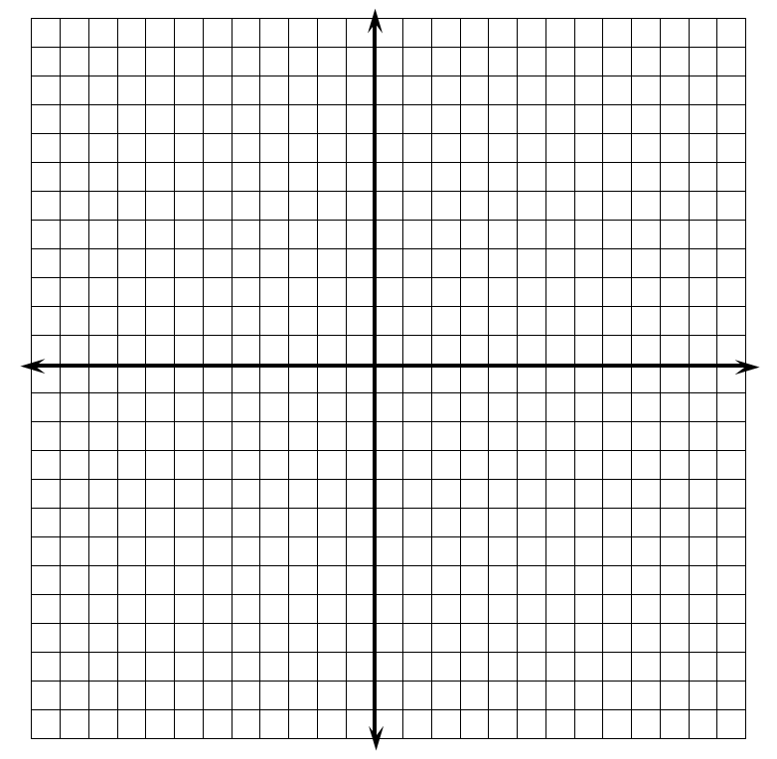
- Locate and label at least five points on the coordinate plane that have an $x$-coordinate of $6$.
  - What is true of the $y$-coordinates below the $x$-axis?
  - What is true of the $y$-coordinates above the $x$-axis?
  - What must be true of the$y$-coordinates on the $x$-axis?

