Lesson 14: Ordered Pairs

Problem Set

- Use the set of ordered pairs below to answer each question.
$$\{(4, 20), (8, 4), (2, 3), (15, 3), (6, 15), (6, 30), (1, 5), (6, 18), (0, 3)\}$$
  - Write the ordered pair(s) whose first and second coordinate have a greatest common factor of $3$.
  - Write the ordered pair(s) whose first coordinate is a factor of its second coordinate.
  - Write the ordered pair(s) whose second coordinate is a prime number.

- Write ordered pairs that represent the location of points $A$, $B$, $C$, and $D$, where the first coordinate represents the horizontal direction, and the second coordinate represents the vertical direction.
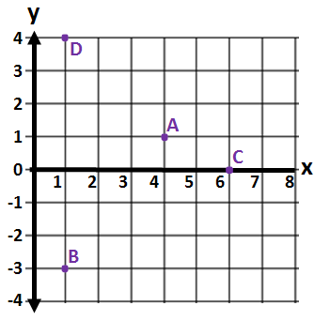

Extension:
- Write ordered pairs of integers that satisfy the criteria in each part below. Remember that the origin is the point whose coordinates are $\left(0, 0\right)$. When possible, give ordered pairs such that (i) both coordinates are positive, (ii) both coordinates are negative, and (iii) the coordinates have opposite signs in either order.
  - These points’ vertical distance from the origin is twice their horizontal distance.
  - These points’ horizontal distance from the origin is two units more than the vertical distance.
  - These points’ horizontal and vertical distances from the origin are equal, but only one coordinate is positive.

