Lesson 2: Using the Number Line to Model the Addition of Integers

Problem Set

Represent Problems 1–3 using both a number line diagram and an equation.
- David and Victoria are playing the Integer Card Game. David drew three cards, $-6$, $12$, and $-4$. What is the sum of the cards in his hand? Model your answer on the number line below.

- In the Integer Card Game, you drew the cards, $2$, $8$, and $-11$. Your partner gave you a $7$ from his hand.
  - What is your total? Model your answer on the number line below.

  - What card(s) would you need to get your score back to zero? Explain. Use and explain the term additive inverse in your answer.

- If a football player gains $40$ yards on a play, but on the next play, he loses $10$ yards, what would his total yards be for the game if he ran for another $60$ yards? What did you count by to label the units on your number line?

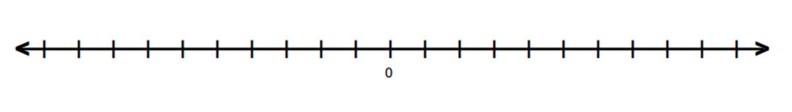

- Find the sums.
  - $-2+9$
  - $-8+-8$
  - $-4+(-6)+10$
  - $5+7+(-11)$

- Mark an integer between $1$ and $5$ on a number line, and label it point $Z$. Then, locate and label each of the following points by finding the sums.

  - Point $A$: $Z+5$
  - Point $B$: $Z+(-3)$
  - Point $C$: $(-4)+(-2)+Z$
  - Point $D$: $-3+Z+1$

- Write a story problem that would model the sum of the arrows in the number diagram below.

- Do the arrows correctly represent the equation $4+(-7)+5=2$? If not, draw a correct model below.

