Lesson 4: Creating a Histogram

Problem Set

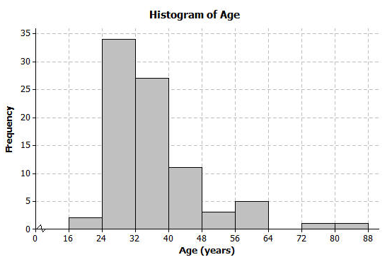
- The following histogram shows ages of the actresses whose performances have won in the Best Leading Actress category at the annual Academy Awards (Oscars).

  - Which age interval contains the most actresses? How many actresses are represented in that interval?
  - Describe the shape of the histogram.
  - What does the shape tell you about the ages of actresses who win the Oscar for best actress award?
  - Which interval describes the center of the ages of the actresses?
  - An age of $72$ would be included in which interval?

- The frequency table below shows the seating capacity of arenas for NBA basketball teams

Number of Seats | Tally | Frequency
$$17000-<17500$$ | || | $$2$$
$$17500-<18000$$ | | | $$1$$
$$18000-<18500$$ | |||| | | $$6$$
$$18500-<19000$$ | |||| | $$5$$
$$19000-<19500$$ | |||| | $$5$$
$$19500-<20000$$ | |||| | $$5$$
$$20000-<20500$$ | || | $$2$$
$$20500-<21000$$ | || | $$2$$
$$21000-<21500$$ |  | $$0$$
$$21500-<22000$$ |  | $$0$$
$$22000-<22500$$ | | | $$1$$

  - Draw a histogram of the number of seats in NBA arenas. Use the histograms you have seen throughout this lesson to help you in the construction of your histogram.
  - What is the width of each interval? How do you know?
  - Describe the shape of the histogram.
  - Which interval describes the center of the number of seats?

- Listed are the grams of carbohydrates in hamburgers at selected fast food restaurants.
$$33 40 66 45 28 30 52 40 26 42 \\ 42 44 33 44 45 32 45 45 52 24$$
  - Complete the frequency table with intervals of width $5$.

Number of Carbohydrates (grams) | Tally | Frequency
$$20-<25$$
$$25-<30$$
$$30-<35$$
$$35-<40$$
$$40-<45$$
$$45-<50$$
$$50-<55$$
$$55-<60$$
$$60-<65$$
$$65-<70$$

  - Draw a histogram of the carbohydrate data.

  - Describe the center and shape of the histogram.

  - In the frequency table below, the intervals are changed. Using the carbohydrate data above, complete the frequency table with intervals of width $10$.

Number of Carbohydrates (grams) | Tally | Frequency
$$20-<30$$
$$30-<40$$
$$40-<50$$
$$50-<60$$
$$60-<70$$

  - Draw a histogram.

- Use the histograms that you constructed in question 3 parts (b) and (e) to answer the following questions.
  - Why are there fewer bars in the histogram in question 3 part (e) than the histogram in part (b)?
  - Did the shape of the histogram in question 3 part (e) change from the shape of the histogram in part (b)?
  - Did your estimate of the center change from the histogram in question 3 part (b) to the histogram in part (e)?

