Lesson 3: Solving for Unknown Angles Using Equations

Problem Set

1. Two lines meet at a point. Set up and solve an equation to find the value of $x$.
2. 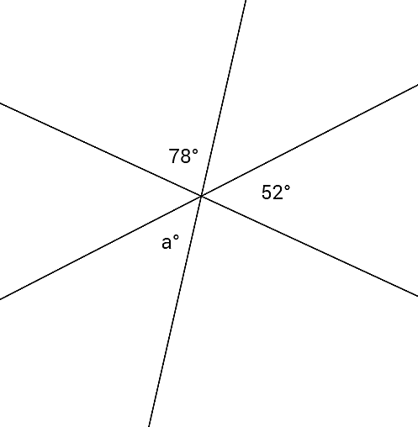Three lines meet at a point. Set up and solve an equation to find the value of $a$. Is your answer reasonable?   
   Explain how you know.
3. Two lines meet at a point that is also the endpoint of two rays. Set up and solve an equation to find the values of $a$ and $b$.



1. Three lines meet at a point that is also the endpoint of a ray. Set up and solve an equation to find the values of $x$ and $y$.



1. Two lines meet at a point. Find the measurement of one of the vertical angles. Is your answer reasonable?   
   Explain how you know.

1. Three lines meet at a point that is also the endpoint of a ray. Set up and solve an equation to find the value of $y$*.*
2. Three adjacent angles are at a point. The second angle is $20°$ more than the first, and the third angle is $20°$ more than the second angle.

a. Find the measurements of all three angles.

b. Compare the expressions you used for the three angles and their combined expression. Explain how they are equal and how they reveal different information about this situation.

1. Four adjacent angles are on a line. The measurements of the four angles are four consecutive even numbers. Determine the measurements of all four angles.
2. Three adjacent angles are at a point. The ratio of the measurement of the second angle to the measurement of the first angle is $4:3$. The ratio of the measurement of the third angle to the measurement of the second angle is $5:4$. Determine the measurements of all three angles.
3. Four lines meet at a point. Solve for $x$ and $y$ in the following diagram.

