Lesson 2: Solving for Unknown Angles Using Equations

Problem Set



1. Two lines meet at a point that is also the endpoint of a ray.   
   Set up and solve an equation to find the value of $c$.
2. Two lines meet at a point that is also the endpoint of a ray. Set up and solve an equation to find the value of $a$. Explain why your answer is reasonable.
3. 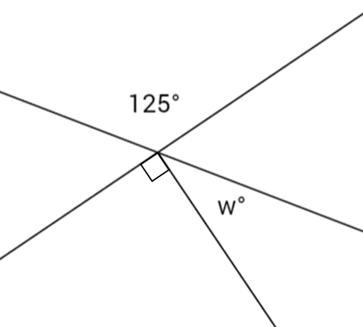Two lines meet at a point that is also the endpoint of a ray. Set up and solve an equation to find the value of $w$.
4. Two lines meet at a point that is also the vertex of an angle. Set up and solve an equation to find the value of $m$.
5. Three lines meet at a point. Set up and solve an equation to find the value of $r$.
6. Three lines meet at a point that is also the endpoint of a ray. Set up and solve an equation to find the value of each variable in the diagram.
7. Set up and solve an equation to find the value of $x$. Find the measurement of $∠AOB$ and of .



1. 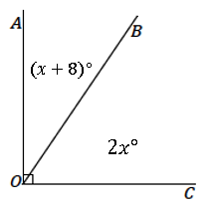Set up and solve an equation to find the value of $x$. Find the measurement of $∠AOB$ and of $∠BOC$.
2. Set up and solve an equation to find the value of $x$. Find the measurement of $∠AOB$ and of $∠BOC$.



1. Write a verbal problem that models the following diagram. Then, solve for the two angles.

