Lesson 20: Real-World Area Problems

Problem Set

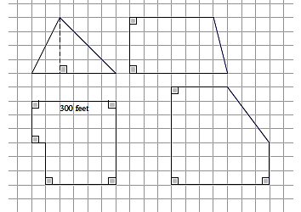
- A farmer has four pieces of unfenced land as shown to the right in the scale drawing where the dimensions of one side are given. The farmer trades all of the land and $\$10,000$ for $8 acres$ of similar land that is fenced. If one acre is equal to $43,560 ft^{2}$, how much per square foot for the extra land did the farmer pay rounded to the nearest cent?

- An ordinance was passed that required farmers to put a fence around their property. The least expensive fences cost $\$10$ for each foot. Did the farmer save money by moving the farm?

- A stop sign is an octagon (i.e., a polygon with eight sides) with eight equal sides and eight equal angles. The dimensions of the octagon are given. One side of the stop sign is to be painted red. If Timmy has enough paint to cover $500 ft^{2}$, can he paint $100$ stop signs? Explain your answer.
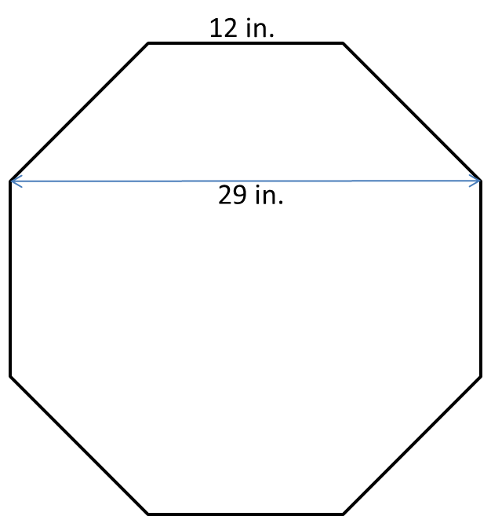

- The Smith family is renovating a few aspects of their home. The following diagram is of a new kitchen countertop. Approximately how many square feet of counter space is there?
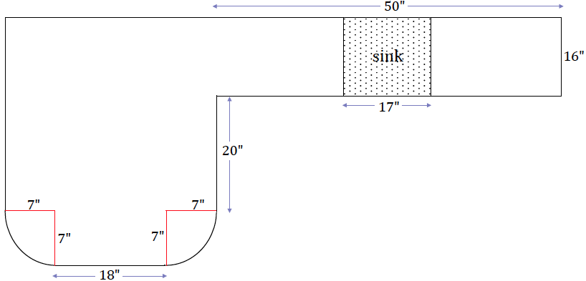

- In addition to the kitchen renovation, the Smiths are laying down new carpet. Everything but closets, bathrooms, and the kitchen will have new carpet. How much carpeting must be purchased for the home?

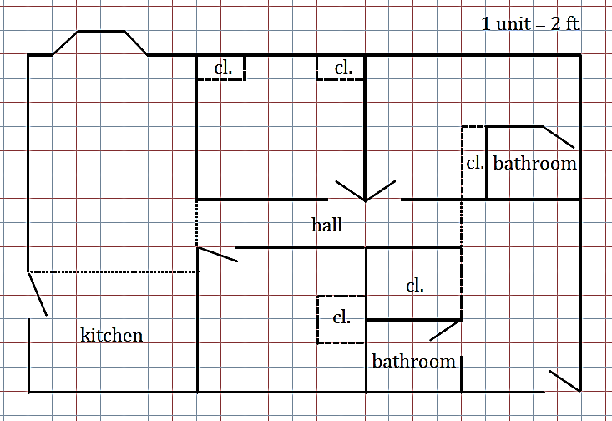

- Jamie wants to wrap a rectangular sheet of paper completely around cans that are $8\frac{1}{2} in.$ high and $4 in.$ in diameter. She can buy a roll of paper that is $8\frac{1}{2} in.$ wide and $60 ft.$ long. How many cans will this much paper wrap?

