Lesson 1: Complementary and Supplementary Angles

Problem Set

1. Two lines meet at a point that is also the endpoint of a ray. Set up and solve the appropriate equations to determine $x$ and $y$.

1. Two lines meet at a point that is also the vertex of an angle. Set up and solve the appropriate equations to determine $x$ and $y$.

1. Two lines meet at a point that is also the vertex of an angle. Set up and solve an appropriate equation for $x$ and $y$.
2. 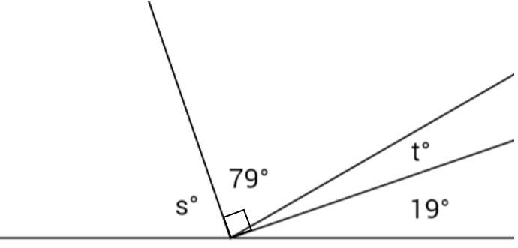Set up and solve the appropriate equations for $s$ and $t$.
3. 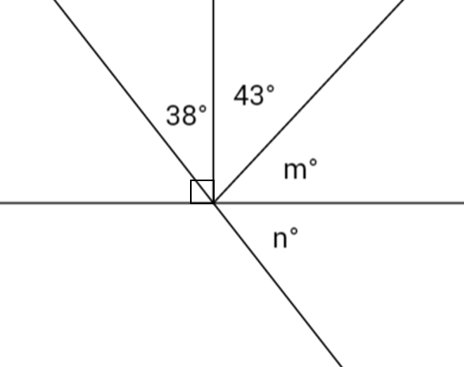Two lines meet at a point that is also the endpoint of two rays. Set up and solve the appropriate equations for $m$ and $n$.
4. The supplement of the measurement of an angle is $16°$ less than three times the angle. Find the measurement of the angle and its supplement.
5. The measurement of the complement of an angle exceeds the measure of the angle by $25\%$. Find the measurement of the angle and its complement.
6. The ratio of the measurement of an angle to its complement is $1:2$. Find the measurement of the angle and its complement.
7. The ratio of the measurement of an angle to its supplement is $3:5$. Find the measurement of the angle and its supplement.
8. Let $x$ represent the measurement of an acute angle in degrees. The ratio of the complement of $x$ to the supplement of $x$ is $2:5$. Guess and check to determine the value of $x$. Explain why your answer is correct.