Lesson 16: Understanding Box Plots

Problem Set

- The box plots below summarize the ages at the time of the award for leading actress and leading actor Academy Award winners.
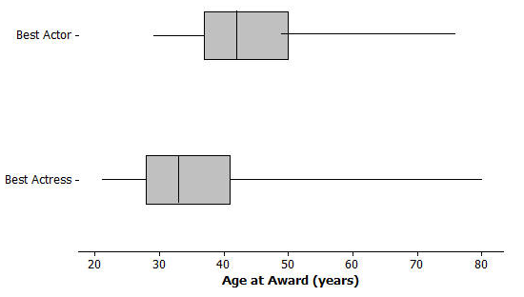
Data Source: http://en.wikipedia.org/wiki/List_of_Best_Actor_winners_by_age_at_win http://en.wikipedia.org/wiki/List_of_Best_Actress_winners_by_age_at_win

  - Do you think it is harder for an older woman to win an academy award for best actress than it is for an older man to win a best actor award? Why or why not?
  - The oldest female to win an academy award was Jessica Tandy in 1990 for Driving Miss Daisy. The oldest actor was Henry Fonda for On Golden Pond in 1982. How old were they when they won the award? How can you tell? Were they a lot older than most of the other winners?
  - The 2013 winning actor was Daniel Day-Lewis for Lincoln. He was $55$ years old at that time. What can you say about the percent of male award winners who were older than Daniel Day-Lewis when they won their Oscar?
  - Use the information you can see in the box plots to write a paragraph supporting or refuting the claim that fewer older actresses than actors win academy awards.

- The scores of sixth and seventh graders on a test about polygons and their characteristics are summarized in the box plots below.
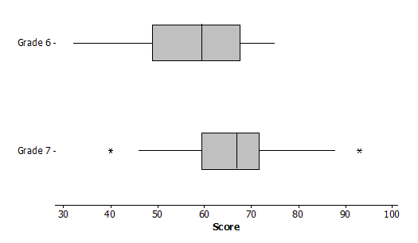

  - In which grade did the students do the best? Explain how you can tell.
  - Why do you think two of the data values in grade seven are not part of the line segments?
  - How do the median scores for the two grades compare? Is this surprising? Why or why not?
  - How do the IQRs compare for the two grades?

- A formula for IQR could be written as $Q3-Q1=IQR$. Suppose you knew the IQR and the Q1. How could you find the Q3?

- Consider the statement, “Historically, the average length of service as Chief Justice on the Supreme Court has been less than $15$ years; however, since 1970 the average length of service has increased.” Use the data given in Exercise 1 to answer the following questions.
  - Do you agree or disagree with the statement? Explain your thinking.
  - Would your answer change if you used the median number of years rather than the mean?

