Lesson 15: More Practice with Box Plots

Problem Set

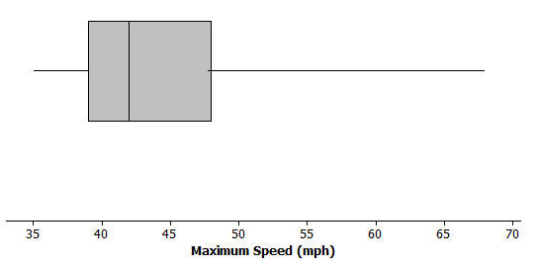
- The box plot below summarizes the maximum speeds of certain kinds of fish.

  - Estimate the $5$-number summary from the box plot.
  - The fastest fish is the sailfish at $68$ mph followed by the marlin at $50$ mph. What does this tell you about the spread of the fish speeds in the top quarter of the plot?
  - Use the $5$-number summary and the IQR to describe the speeds of the fish.

- Suppose you knew that the interquartile range for the number of hours students spent playing video games during the school week was $10$. What do you think about each of the following statements? Explain your reasoning.
  - About half of the students played video games for $10$ hours during a school week.
  - All of the students played at least $10$ hours of video games during the school week.
  - About half of the class could have played video games from $10$ to $20$ hours a week or from $15$ to $25$ hours.
- Suppose you know the following for a data set: minimum value is $130$, the lower quartile is $142$, the IQR is $30$, half of the data are less than $168$, and the maximum value is $195$.
  - Think of a context for which these numbers might make sense.
  - Sketch a box plot.
  - Are there more data values above or below the median? Explain your reasoning.

- The speeds for the fastest dogs are given in the table below.

Breed | Speed (mph) |  | Breed | Speed (mph)
Greyhound | $$45$$ |  | Irish Wolfhound | $$30$$
African Wild Dog | $$44$$ |  | Dalmatian | $$30$$
Saluki | $$43$$ |  | Border Collie | $$30$$
Whippet | $$36$$ |  | Alaskan Husky | $$28$$
Basanji | $$35$$ |  | Giant Schnauzer | $$28$$
German Shepherd | $$32$$ |  | Jack Russell Terrier | $$25$$
Vizsla | $$32$$ |  | Australian Cattle Dog | $$20$$
Doberman Pinscher | $$30$$
Data Source: http://www.vetstreet.com/our-pet-experts/meet-eight-of-the-fastest-dogs-on-the-planet; http://canidaepetfood.blogspot.com/2012/08/which-dog-breeds-are-fastest.html

  - Find the $5$-number summary for this data set and use it to create a box plot of the speeds.
  - Why is the median not in the center of the box?
  - Write a few sentences telling your brother or sister about the speed of the fastest dogs.

