Lesson 14: Summarizing a Distribution Using a Box Plot
Problem Set

- Dot plots for the amount of time it took students in Mr. S’s and Ms. J’s classes to get to school are below
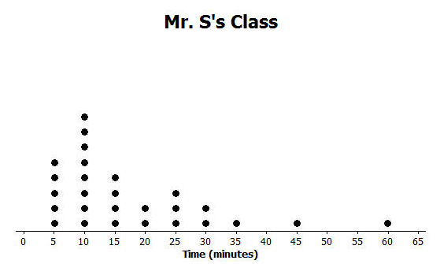
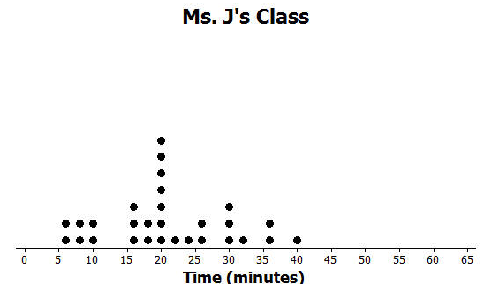
  - Make a box plot of the times for each class.
  - What is one thing you can see in the dot plot that you cannot see in the box plot? What is something that is easier to see in the box plot than in the dot plot?

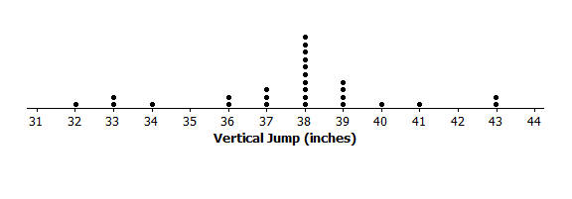
- The dot plot below shows the vertical jump of some NBA players. A vertical jump is how high a player can jump from a standstill. Draw a box plot of the heights for the vertical jumps of the NBA players above the dot plot.

- The mean daily temperatures in °F for the month of February for a certain city are as follows:
$4$, $11$,$14$,$15$,$17$,$20$,$30$,$23$,$20$,$35$,$35$,$31$,$34$,$23$,$15$,$19$,$39$,$22$,$15$,$15$,$19$,$39$,$22$,$23$,$29$,$26$,$29$,$29$
  - Make a box plot of the temperatures.
  - Make a prediction about the part of the United States you think the city might be located. Explain your reasoning.
  - Describe the data distribution of temperature. Include a description of the center and spread.

- The plot below shows the results of a survey of households about the number of dogs they have. Identify the following statements as true or false. Explain your reasoning in each case.
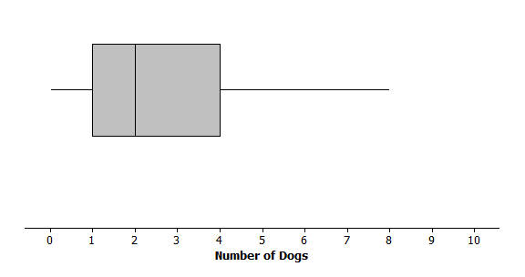
  - The maximum number of dogs per house is $8$.
  - At least $\frac{1}{2}$ of the houses have $2$ or more dogs.
  - All of the houses have dogs.
  - Half of the houses surveyed have between $2$ and $4$ dogs.
  - Most of the houses surveyed have no dogs.

