Lesson 13: Describing Variability using the Interquartile Range (IQR)
Problem Set

- The average monthly high temperatures (in °F) for St. Louis and San Francisco are given in the table below.

 | Jan | Feb | Mar | Apr | May | June | July | Aug | Sept | Oct | Nov | Dec
St. Louis | $$40$$ | $$45$$ | $$55$$ | $$67$$ | $$77$$ | $$85$$ | $$89$$ | $$88$$ | $$81$$ | $$69$$ | $$56$$ | $$43$$
San Francisco | $$57$$ | $$60$$ | $$62$$ | $$63$$ | $$64$$ | $$67$$ | $$67$$ | $$68$$ | $$70$$ | $$69$$ | $$63$$ | $$57$$
Data Source: www.weather.com/weather/wxclimatology/monthly/graph/USCA0987
www.weather.com/weather/wxclimatology/monthly/graph/USMO0787

  - How do you think the data might have been collected?
  - Do you think it would be possible for $\frac{1}{4}$ of the temperatures in the month of July for St. Louis to be $95°$ or above? Why or why not?
  - Make a prediction about how the sizes of the IQR for the temperatures for each city compare. Explain your thinking.
  - Find the IQR for the average monthly high temperature for each city. How do the results compare to your conjecture?

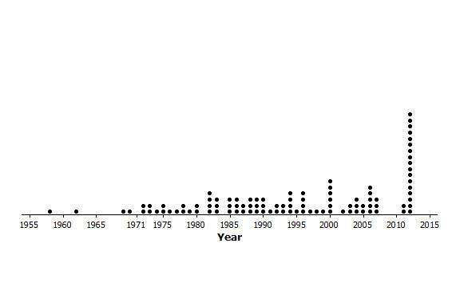
- The plot below shows the years in which each of $100$ pennies were made.

  - What does the stack of $17$ dots at 2012 representing $17$ pennies tell you about the “age” of the pennies in 2014?
  - Here is some information about the sample of pennies. The mean year they were made is 1994; the first year any of the pennies were made was 1958; the newest pennies were made in 2012; Q1 is 1984, the median is 1994, and Q3 is 2006; the MAD is $11.5$ years. Use the information to indicate the years in which the middle half of the pennies was made.

- Create a data set with at least $6$ elements such that it has the following:
  - A small IQR and a big range (maximum-minimum).
  - An IQR equal to the range.
  - The lower quartile is the same as the median.

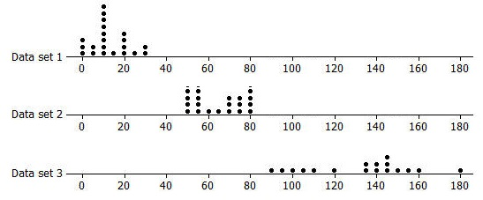
- Rank the following three data sets by the value of the IQR.

- Here are the counts of the fries in each of the bags from Restaurant A: $80, 72, 77, 80, 90, 85, 93, 79, 84, 73, 87, 67, 80, 86, 92, 88, 86, 88, 66,$and$77$.
  - Suppose one bag of fries had been overlooked in the sample and that bag had only $50$ fries. Would the IQR change? Explain your reasoning.
  - Will adding another data value always change the IQR? Give an example to support your answer.

