Lesson 12: Describing the Center of a Distribution Using the Median
Problem Set

- The amount of precipitation in the western states in the U.S. is given in the table as well as the graph.
State | Amount of Precipitation (in.)
WA | $$38.4$$
OR | $$27.4$$
CA | $$22.2$$
MT | $$15.3$$
ID | $$18.9$$
WY | $$12.9$$
NV | $$9.5$$
UT | $$12.2$$
CO | $$15.9$$
AZ | $$13.6$$
NM | $$14.6$$
AK | $$58.3$$
HI | $$63.7$$
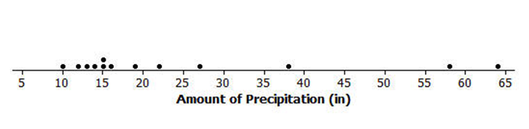
Data Source: http://www.currentresults.com/Weather/US/average-annual-state-precipitation.php
  - How do the amounts vary across the states?
  - Find the median. What does the median tell you about the amount of precipitation?
  - Use the median and the range to describe the average monthly precipitation in western states in the U.S.
  - Do you think the mean or median would be a better description of the typical amount of precipitation? Explain your thinking.

- Identify the following as true or false. If a statement is false, give an example showing why.
  - The median is always equal to one of the values in the data set.
  - The median is the midpoint between the smallest and largest values in the data set.
  - At most, half of the values in a data set have values less than the median.
  - In a data set with $25$ different values, if you change the two smallest values of a data set to smaller values, the median will not be changed.
  - If you add $10$ to every element of a data set, the median will not change.

- Make up a data set such that the following is true:
  - The set has $11$ different values and the median is $5$.
  - The set has $10$ values and the median is $25$.
  - The set has $7$ values and the median is the same as the smallest value.

- The dot plot shows the number of landline phones that a sample of people have in their homes.
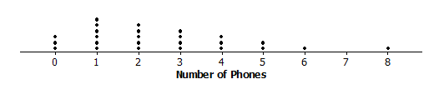

  - How many people were in the sample?
  - Why do you think three people have no landline phones in their homes?
  - Find the median number of phones for the people in the sample.
  - Use the median and the range (maximum-minimum) to describe the distribution of the number of phones.

Player | Salary ($\$$)
Kobe Bryant | $$\$27,849,149$$
Dwight Howard | $$\$19,536,360$$
Pau Gasol | $$\$19,000,000$$
Steve Nash | $$\$8,700,000$$
Metta World Peace | $$\$7,258,960$$
Steve Blake | $$\$4,000,000$$
Jordan Hill | $$\$3,563,600$$
Chris Duhon | $$\$3,500,000$$
Jodie Meeks | $$\$1,500,000$$
Earl Clark | $$\$1,240,000$$
Devin Ebanks | $$\$1,054,389$$
Darius Morris | $$\$962,195$$
Antawn Jamison | $$\$854,389$$
Robert Sacre | $$\$473,604$$
Darius Johnson-Odom | $$\$203,371$$
- The salaries of the Los Angeles Lakers for the 2012–2013 basketball season are given below.
Data Source: www.basketball-reference.com/contracts/LAL.html
  - Just looking at the data, what do you notice about the salaries?
  - Find the median salary, and explain what it tells you about the salaries.
  - Find the median of the lower half of the salaries and the median of the upper half of the salaries.
  - Find the width of each of the following intervals. What do you notice about the size of the interval widths, and what does that tell you about the salaries?
    - minimum salary to median of the lower half:
    - median of the lower half to the median of the whole set:
    - median of the whole set to the median of the upper half:
    - median of the upper half to the highest salary:

- Use the salary table from above to answer the following.
  - If you were to find the mean salary, how do you think it would compare to the median? Explain your reasoning.
  - Which measure do you think would give a better picture of a typical salary for the Lakers, the mean or the median? Explain your thinking.

