Lesson 19: Unknown Area Problems on the Coordinate Plane

Problem Set

Find the area of each figure.
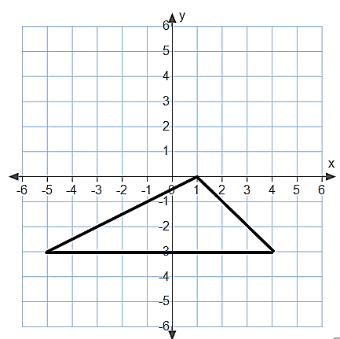 | 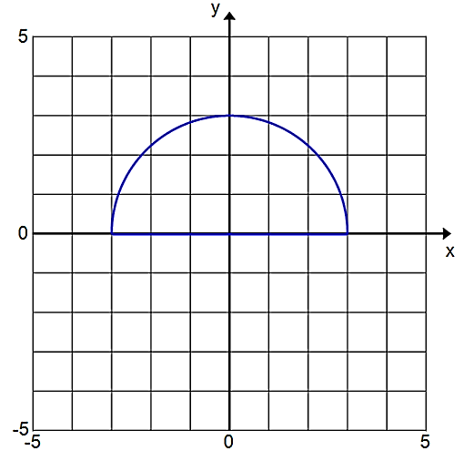
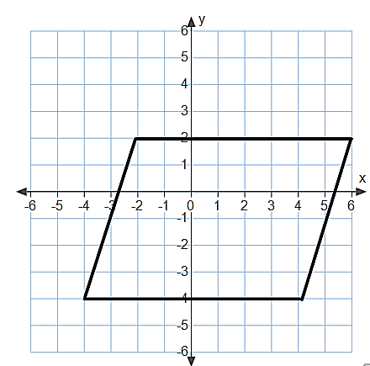 | 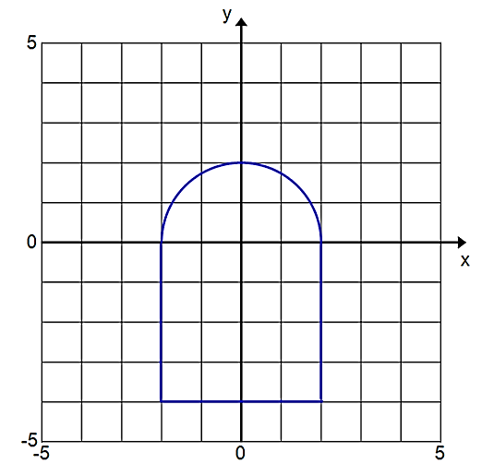
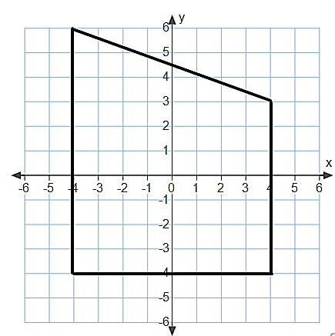 | 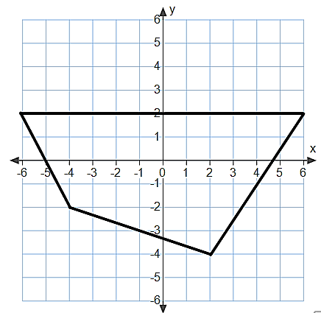
For Problems 7–9, draw a figure in the coordinate plane that matches each description.

- A rectangle with an area of $18$ sq. units | - A parallelogram with an area of $50$ sq. units | - A triangle with an area of $25$ sq. units
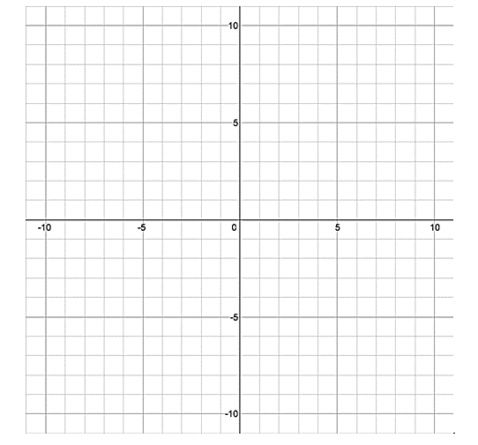

Find the unknown value labelled as $x$ on each figure.
- The rectangle has an area of $80$ sq. units.
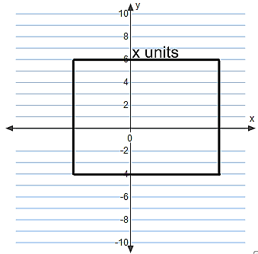

- The trapezoid has an area of $115$ sq. units.
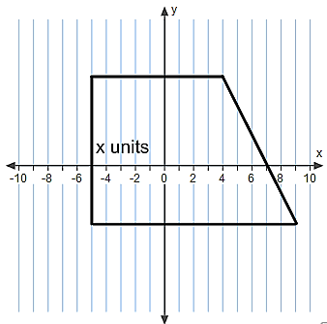

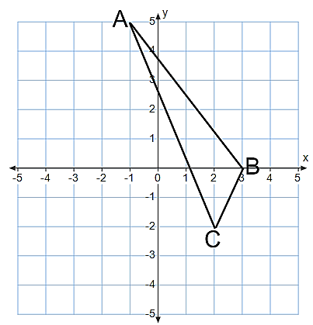
- Find the area of triangle $ABC$.

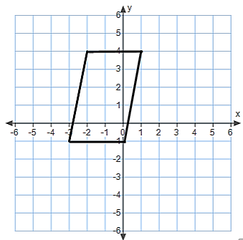
- Find the area of the quadrilateral using two different methods. Describe the methods used, and explain why they result in the same area.

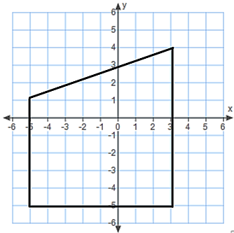
- Find the area of the quadrilateral using two different methods. What are the advantages or disadvantages of each method?

