Lesson 17: The Area of a Circle
Problem Set

- The following circles are not drawn to scale. Find the area of each circle. (Use $\frac{22}{7}$ as an approximation for $π.$)
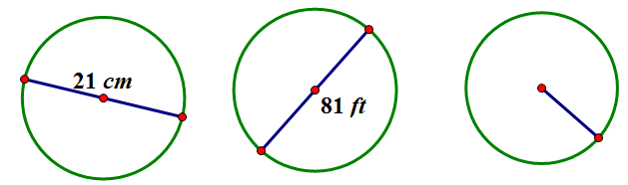
$$\frac{45}{2}cm$$

- A circle has a diameter of $20$ inches.
  - Find the exact area, and find an approximate area using $π≈3.14$.
  - What is the circumference of the circle using$π$ $≈3.14$?
- A circle has a diameter of $11$ inches.
  - Find the exact area and an approximate area using $π≈3.14$.
  - What is the circumference of the circle using $π≈3.14$?
- Using the figure below, find the area of the circle.
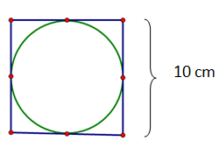

- A path bounds a circular lawn at a park. If the inner edge of the path is $132 ft.$ around, approximate the amount of area of the lawn inside the circular path. Use $π≈\frac{22}{7}$.
- The area of a circle is $36π{ cm}^{2}$. Find its circumference.
- Find the ratio of the area of two circles with radii $3 cm$ and $4 cm$.
- If one circle has a diameter of $10 cm$ and a second circle has a diameter of $20 cm$, what is the ratio of the area of the larger circle to the area of the smaller circle?
- Describe a rectangle whose perimeter is $132 ft.$ and whose area is less than $1 {ft}^{2}$. Is it possible to find a circle whose circumference is $132 ft.$ and whose area is less than $1 {ft}^{2}$? If not, provide an example or write a sentence explaining why no such circle exists.
- If the diameter of a circle is double the diameter of a second circle, what is the ratio of area of the first circle to the area of the second?

