Lesson 16: The Most Famous Ratio of All

Problem Set

1. 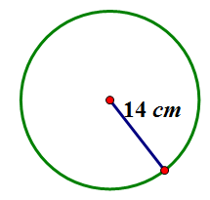Find the circumference.
   1. Give an exact answer in terms of $π$.
   2. Use $π≈\frac{22}{7}$ and express your answer as a fraction in lowest terms.
   3. Use $the π$ button on your calculator, and express your answer to the nearest hundredth.

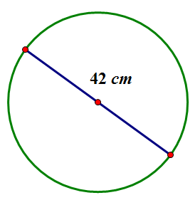Find the circumference.

* 1. Give an exact answer in terms of $π$.
  2. Use $π≈\frac{22}{7}$, and express your answer as a fraction in lowest terms.

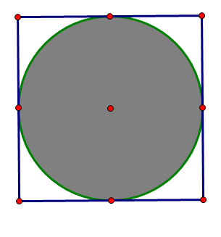

$$16 in.$$

1. The figure shows a circle within a square. Find the circumference of the circle. Let $π≈3.14$.
2. 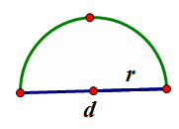Consider the diagram of a semicircle shown.
   1. Explain in words how to determine the perimeter of a semicircle.
   2. Using $d$ to represent the diameter of the circle, write an algebraic equation that will result in the perimeter of a semicircle.
   3. Write another algebraic equation to represent the perimeter of a semicircle using $r$ to represent the radius of a semicircle.
3. Find the perimeter of the semicircle. Let $π≈3.14$.

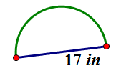

1. Ken’s landscape gardening business makes odd-shaped lawns that include semicircles. Find the length of the edging material needed to border the two lawn designs. Use $3.14$ for $π$.
   1. 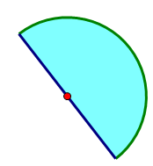The radius of this flower bed is $2.5 m$.
   2. The diameter of the semicircular section is $10 m$, and the lengths of the sides of the two sides are $6 m$.

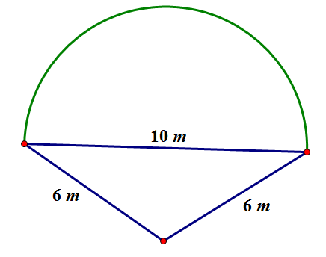

1. 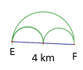Mary and Margaret are looking at a map of a running path in a local park. Which is the shorter path from $E$ to $F$, along the two semicircles or along the larger semicircle? If one path is shorter, how much shorter is it? Let $π≈3.14$.
2. 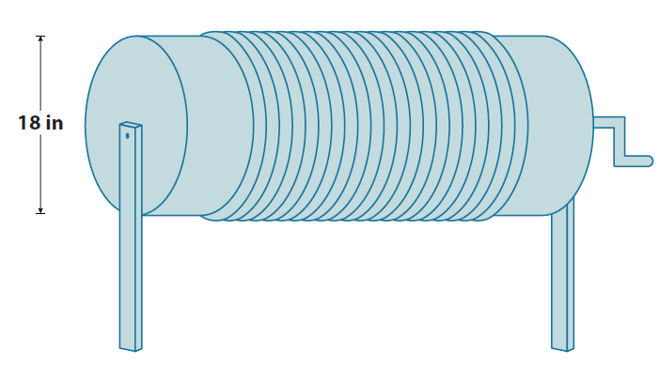Alex the electrician needs $34$ yards of electrical wire to complete a job. He has a coil of wiring in his workshop. The coiled wire is $18$ inches in diameter and is made up of $21$ circles of wire. Will this coil be enough to complete the job? Let $π≈3.14$.