Lesson 8: Representing Proportional Relationships with Equations

Problem Set

Write an equation that will model the proportional relationship given in each real-world situation.
- There are $3$ cans that store $9$ tennis balls. Consider the number of balls per can.
  - Find the constant of proportionality for this situation.
  - Write an equation to represent the relationship.

- In $25$ minutes Li can run $10$ laps around the track. Determine the number of laps she can run per minute.
  - Find the constant of proportionality in this situation.
  - Write an equation to represent the relationship.

- Jennifer is shopping with her mother. They pay $\$2$ per pound for tomatoes at the vegetable stand.
  - Find the constant of proportionality in this situation.
  - Write an equation to represent the relationship.

- It costs $\$15$ to send $3$ packages through a certain shipping company. Consider the number of packages per dollar.
  - Find the constant of proportionality for this situation.
  - Write an equation to represent the relationship.
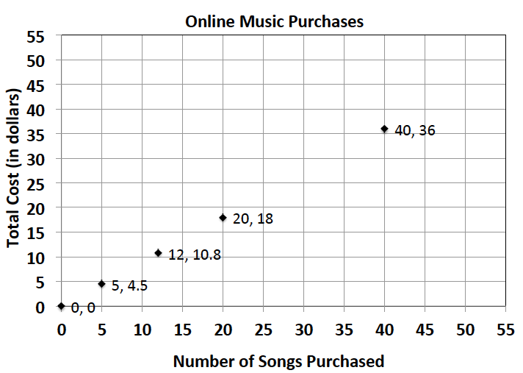
- On average, Susan downloads $60$ songs per month. An online music vendor sells package prices for songs that can be downloaded onto personal digital devices. The graph below shows the package prices for the most popular promotions. Susan wants to know if she should buy her music from this company or pay a flat fee of $\$58.00$ per month offered by another company. Which is the better buy?
  - Find the constant of proportionality for this situation.
  - Write an equation to represent the relationship.
  - Use your equation to find the answer to Susan’s question above. Justify your answer with mathematical evidence and a written explanation.

- Allison’s middle school team has designed t-shirts containing their team name and color. Allison and her friend Nicole have volunteered to call local stores to get an estimate on the total cost of purchasing t-shirts. Print-o-Rama charges a set-up fee, as well as a fixed amount for each shirt ordered. The total cost is shown below for the given number of shirts. Value T’s and More charges $\$8$ per shirt. Which company should they use?
Print-o-Rama
Number of Shirts (S) | Total Cost (C)
$$10$$ | $$95$$
$$25$$
$$50$$ | $$375$$
$$75$$
$$100$$
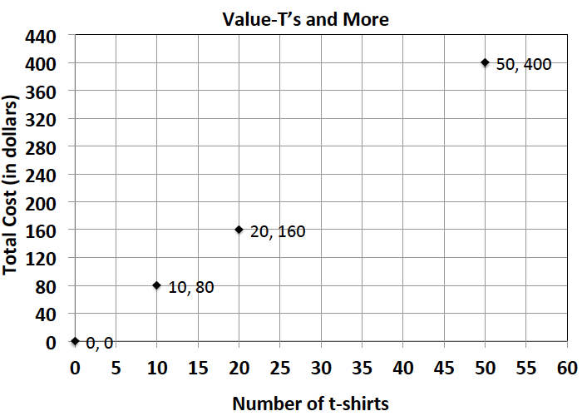

  - Does either pricing model represent a proportional relationship between the quantity of t-shirts and the total cost? Explain.
  - Write an equation relating cost and shirts for Value T’s and More.
  - What is the constant of proportionality of Value T’s and More? What does it represent?
  - How much is Print-o-Rama’s set-up fee?
  - If you need to purchase $90$ shirts, write a proposal to your teacher indicating which company the team should use. Be sure to support your choice. Determine the number of shirts that you need for your team.

