Lesson 26: Percent of a Quantity

Classwork
Example 1
Five of the $25$ girls on Alden Middle School’s soccer team are seventh-grade students. Find the percentage of seventh graders on the team. Show two different ways of solving for the answer. One of the methods must include a diagram or picture model.

Example 2
Of the $25$ girls on the Alden Middle School soccer team, $40\%$ also play on a travel team. How many of the girls on the middle school team also play on a travel team?
Example 3
The Alden Middle School girls’ soccer team won $80\%$ of its games this season. If the team won $12$ games, how many games did it play? Solve the problem using at least two different methods.

Exercises
- There are $60$ animal exhibits at the local zoo. What percent of the zoo’s exhibits does each animal class represent?

Exhibits by Animal Class | Number of Exhibits | Percent of the Total  Number of Exhibits
Mammals | $$30$$
Reptiles & Amphibians | $$15$$
Fish & Insects | $$12$$
Birds | $$3$$

- A sweater is regularly $\$32$. It is $25\%$off the original price this week.
  - Would the amount the shopper saved be considered the part, whole, or percent?

  - How much would a shopper save by buying the sweater this week? Show two methods for finding your answer.

- A pair of jeans was $30\%$ off the original price. The sale resulted in a $\$24$ discount.
  - Is the original price of the jeans considered the whole, part, or percent?

  - What was the original cost of the jeans before the sale? Show two methods for finding your answer.

- Purchasing a TV that is $20\%$ off will save $\$180$.
  - Name the different parts with the words: PART, WHOLE, PERCENT.

$20\%$off $\$180$ Original Price

  - What was the original price of the TV? Show two methods for finding your answer.

Lesson Summary
Models and diagrams can be used to solve percent problems. Tape diagrams, $10×10$grids, double number line diagrams, and others can be used in a similar way to using them with ratios to find the percent, the part, or the whole.
Problem Set

- What is $15\%$ of $60$? Create a model to prove your answer.

- If $40\%$ of a number is $56$, what was the original number?

- In a $10×10$ grid that represents $800$, one square represents ___ .
Use the grids below to represent $17\%$ and $83\%$ of $800$.
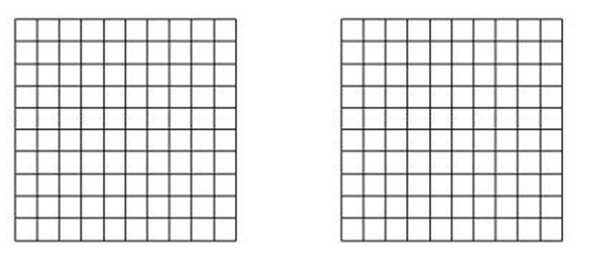
$$83\%$$
$$17\%$$

$17\%$ of $800$ is _________________________. $83\%$ of $800$is _________________________.

