Lesson 25: A Fraction as a Percent

Classwork

**Example 1**

**j0212957j0212957j0212957MC900320956[1]MC900320956[1]**

Sam says $50$% of the vehicles are cars. Give three different reasons or models that prove or disprove Sam’s statement. Models can include tape diagrams, $10×10$ grids, double number lines, etc.

How is the fraction of cars related to the percent?

Use a model to prove that the fraction and percent are equivalent.

What other fractions or decimals also represent $60\%$?

**Example 2**

A survey was taken that asked participants whether or not they were happy with their job. An overall score was given. $300$ of the participants were unhappy while $700$ of the participants were happy with their job. Give a part-to-whole fraction for comparing happy participants to the whole. Then write a part-to-whole fraction of the unhappy participants to the whole. What percent were happy with their job, and what percent were unhappy with their job?

|  |  |  |  |  |  |  |
| --- | --- | --- | --- | --- | --- | --- |
| Happy | _____________________ | ______________ |  | Unhappy | _____________________ | ______________ |
|  | Fraction | Percent |  |  | Fraction | Percent |

Create a model to justify your answer.

Exercise 1

Renita claims that a score of $80\%$ means that she answered $\frac{4}{5}$ of the problems correctly. She drew the following picture to support her claim:

|  |  |  |  |  |  |  |  |  |  |  |  |  |  |  |  |  |  |  |  |
| --- | --- | --- | --- | --- | --- | --- | --- | --- | --- | --- | --- | --- | --- | --- | --- | --- | --- | --- | --- |
|  |  |  |  |  |  |  |  |  |  |  |  |  |  |  |  |  |  |  |  |
|  |  |  |  |  |  |  |  |  |  |  |  |  |  |  |  |  |  |  |  |
|  |  |  |  |  |  |  |  |  |  |  |  |  |  |  |  |  |  |  |  |
|  |  |  |  |  |  |  |  |  |  |  |  |  |  |  |  |  |  |  |  |
|  |  |  |  |  |  |  |  |  |  |  |  |  |  |  |  |  |  |  |  |

Is Renita correct? ______________ Why or why not?

How could you change Renita’s picture to make it easier for Renita to see why she is correct or incorrect?

Exercise 2

Use the diagram to answer the following questions.

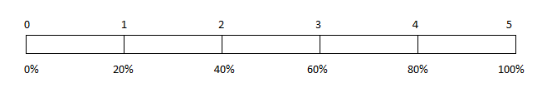

$80\%$ is what fraction of the whole quantity?

$\frac{1}{5}$ is what percent of the whole quantity?

$50\%$ is what fraction of the whole quantity?

$1$ is what percent of the whole quantity?

Exercise 3

Maria completed $\frac{3}{4}$ of her workday. Create a model that represents what percent of the workday Maria has worked.

What percent of her workday does she have left?

How does your model prove that your answer is correct?

Exercise 4

Matthew completed $\frac{5}{8}$ of his workday. What decimal would also describe the portion of the workday he has finished?

How can you use the decimal to get the percent of the workday Matthew has completed?

Exercise 5

Complete the conversions from fraction to decimal to percent.

|  |  |  |
| --- | --- | --- |
| **Fraction** | **Decimal** | **Percent** |
| $$\frac{1}{8}$$ |  |  |
|  | $$0.35$$ |  |
|  |  | $$84.5\%$$ |
|  | $$0.325$$ |  |
| $$\frac{2}{25}$$ |  |  |

Exercise 6

Choose one of the rows from the conversion table in Exercise 5, and use models to prove your answers. (Models could include a $10×10$ grid, a tape diagram, a double number line, etc.)

Lesson Summary

Fractions, decimals, and percentages are all related.

To change a fraction to a percentage, you can scale up or scale down so that $100$ is in the denominator.

Example:

$$\frac{9}{20}=\frac{9×5}{20×5}=\frac{45}{100}=45\%$$

There may be times when it is more beneficial to convert a fraction to a percent by first writing the fraction in decimal form.

Example:

$$\frac{5}{8}=0.625=62.5 \text{hundredths}=62.5\%$$

Models, like tape diagrams and number lines, can also be used to model the relationships.

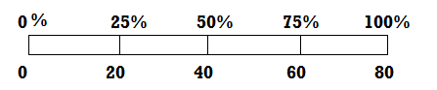

The diagram shows that $\frac{20}{80}=25\%$.

Problem Set

1. 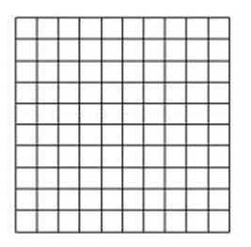Use the $10×10$ grid to express the fraction $\frac{11}{20}$ as a percent.
2. Use a tape diagram to relate the fraction $\frac{11}{20}$ to a percent.
3. How are the diagrams related?
4. What decimal is also related to the fraction?
5. Which diagram is the most helpful for converting the fraction to a decimal? _______________ Explain why.