Lesson 24: Percent and Rates per 100

Student Outcomes
- Students understand that percents are related to part-to-whole ratios and rates where the whole is $100$.
- Students model percents and write a percent as a fraction over $100$ or a decimal to the hundredths place.

Classwork
Example 1 (5 minutes)
Begin class with a discussion to gather prior knowledge and to show a relationship to real-world applications.
- Imagine that you are shopping. You want to purchase an item for $\$100,$ but today it is $20\%$ off. What does this mean?
  - It means that $\$20$ out of every $\$100$ dollars will be subtracted from the total.
- How can this situation be modeled?
  - We could use a tape diagram that represents $\$100$ divided into ten sections of $\$10$. Two of the sections represent the discount, and eight of the sections represent the amount paid for the item.
It could also be shown on a $10×10$ grid, where $20$of the squares represent the discount, and
$80$ squares represent the amount paid.
- How are percent problems related to the types of problems we have been working with involving ratios and rates?
  - Answers will vary depending on prior knowledge. Some students may see that $20\%$ of $\$100$ is $\$20$ off. Other students may see that we are trying to find part of a whole.

Use the following website on a projector to visually explore percents in a $10×10$grid model.
http://nlvm.usu.edu/en/nav/frames_asid_333_g_3_t_1.html?from category_g_3_t_1.html
Click the explore button on the website to be able to show $20\%.$ This provides students with the visual for making the connection that $20\%$means $20$ out of $100$.
- What does this grid show?
- $100$blocks
- How many are shaded in?
- $20$ blocks
- How many are not shaded in?
- $80$blocks
- How can we use this model to help us think through $20\%$ off of $\$100?$
- From the grid, I can see that when I save $20\%,$ I am paying $80\%$ of the original value.
Now they can see that since each block represents $\$1$, they would be saving the $20$ and spending the $80$ when a
$\$100$ item is $20\%$ off the original price.

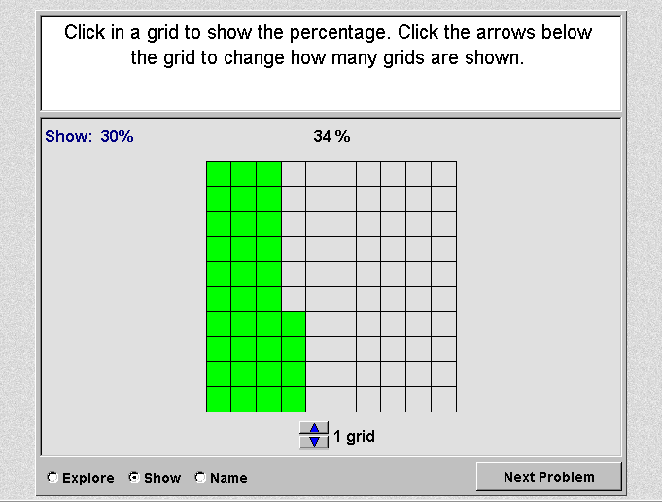
Here is an example of what the website will look like:

If time allows, add more grids to model percents greater than $100\%$ so that students further build an understanding.

Exercises 1–2 (8 minutes)
Solve the following two exercises with student input in order to model the process of working with percents. Students will need coloring utensils in order to complete the remaining activities.
Exercise 1
Robb’s Fruit Farm consists of $100$acres on which three different types of apples grow. On $25$ acres, the farm grows Empire apples. McIntosh apples grow on $30\%$ of the farm. The remainder of the farm grows Fuji apples. Shade in the grid below to represent the portion of the farm each apple type occupies. Use a different color for each type of apple. Create a key to identify which color represents each type of apple.
Color Key Part-to-Whole Ratio
Empire Black (B) $25:100$

McIntosh Purple (P) $30:100$

Fuji Green (G) $45:100$
B | B | G | G | G | G | G | P | P | P
B | B | G | G | G | G | G | P | P | P
B | B | G | G | G | G | G | P | P | P
B | B | G | G | G | G | G | P | P | P
B | B | G | G | G | G | G | P | P | P
B | B | B | G | G | G | G | P | P | P
B | B | B | G | G | G | G | P | P | P
B | B | B | G | G | G | G | P | P | P
B | B | B | G | G | G | G | P | P | P
B | B | B | G | G | G | G | P | P | P

Exercise 2
The shaded portion of the grid below represents the portion of a granola bar remaining.
0.01 | 0.01 | 0.01 | 0.01 | 0.01 | 0.01 | 0.01 | 0.01 | 0.01 | 0.01
0.01 | 0.01 | 0.01 | 0.01 | 0.01 | 0.01 | 0.01 | 0.01 | 0.01 | 0.01
0.01 | 0.01 | 0.01 | 0.01 | 0.01 | 0.01 | 0.01 | 0.01 | 0.01 | 0.01
0.01 | 0.01 | 0.01 | 0.01 | 0.01 | 0.01 | 0.01 | 0.01 | 0.01 | 0.01
0.01 | 0.01 | 0.01 | 0.01 | 0.01 | 0.01 | 0.01 | 0.01 | 0.01 | 0.01
0.01 | 0.01 | 0.01 | 0.01 | 0.01 | 0.01 | 0.01 | 0.01 | 0.01 | 0.01
0.01 | 0.01 | 0.01 | 0.01 | 0.01 | 0.01 | 0.01 | 0.01 | 0.01 | 0.01
0.01 | 0.01 | 0.01 | 0.01 | 0.01 | 0.01 | 0.01 | 0.01 | 0.01 | 0.01
0.01 | 0.01 | 0.01 | 0.01 | 0.01 | 0.01 | 0.01 | 0.01 | 0.01 | 0.01
0.01 | 0.01 | 0.01 | 0.01 | 0.01 | 0.01 | 0.01 | 0.01 | 0.01 | 0.01
What percent does each block of granola bar represent?
$1\%$of the granola bar
What percent of the granola bar remains?
$$80\%$$
What other ways can we represent this percent?
$$\frac{80}{100}\text{,} \frac{8}{10}\text{,} \frac{4}{5}\text{,} \frac{16}{20}\text{,}\frac{32}{ 40}\text{,} \frac{64}{80}\text{,}0.8$$

In this example, the teacher can discuss how $0.01$ is related to $\frac{1}{100}$ and $1\%.$ There are many examples that could be used to represent this percent in the last question. Students should list several examples.

Exercises 3–6 (15 minutes)
In predetermined pairs or groups, students solve the remaining problems.
Circulate around the room. Students may have varying answers for several questions in the practice. There is more than one possible answer for several questions to spark conversation between pairs or small groups.
For example, the second $10×10$grid used two different colors, so students could compare colored to total: light gray to total, dark gray to total. In addition, when they are asked to describe the different scenarios, some may use part-to-part ratios while others may use part-to-whole. This is a good time for a discussion on how part-to-part can lead to
part-to-whole. In addition, it is important to remember that percents are out of a total $100$, so consider asking students which form of the ratio is most helpful for getting a percent.
A percent is just another way to show the part-to-whole ratio for each picture.

Exercise 3
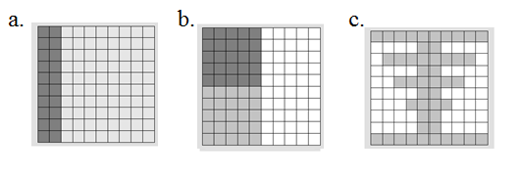

- For each figure shown, represent the gray shaded region as a percent of the whole figure. Write your answer as a decimal, fraction, and percent.
Picture (a) | Picture (b) | Picture (c)
$20\%$ is shaded darker than the rest, $0.20$, $\frac{20}{100}$. | Answers will vary. Sample answer (colored compared to total): $50\%$, $0. 50$, $\frac{50}{100}$ (Students could also compare darker shading to total, lighter shading to total, light shading to darker shading, darker shading to lighter shading, etc.) | $48\%$, $0.48$, $\frac{48}{100}$

- What ratio is being modeled in each picture?
Picture (a): Answers will vary. One example is the ratio of darker gray to the total is $20$ to $100$.
Picture (b): $50$ to $100$, or a correct answer for whichever description they chose.
Picture (c): The ratio of gray to the total is $48$ to $100$.

- How are the ratios and percents related?
Answers will vary.
Exercise 4
Each relationship below compares the shaded portion (or part) to the entire figure (the whole). Complete the table.
Percentage | Decimal | Fraction | Ratio | Model
$$6\%$$ | $$0.06$$ | $$\frac{6}{100}$$ | $$6:100$$

$$60\%$$ | $$0.6$$ | $$\frac{60}{100}\text{,}\frac{6}{10}$$ | $$60:100$$
$$600\%$$ | $$6$$ | $$\frac{600}{100}=\frac{6}{1}$$ | $$6:1$$ | $6$ wholes
$$32\%$$ | $$0.32$$ | $$\frac{32}{100}$$ | $$32:100$$
$$55\%$$ | $$0.55$$ | $$\frac{55}{100}\text{,}\frac{11}{20}$$ | $$11:20$$
$$90\%$$ | $$0.9$$ | $$\frac{9}{10}$$ | $$9:10$$
$$70\%$$ | $$0.7$$ | $$\frac{7}{10}\text{,}\frac{70}{100}$$ | $$7:10$$

Exercise 5
Mr. Brown shares with the class that $70\%$ of the students got an A on the English vocabulary quiz. If Mr. Brown has $100$students, create a model to show how many of the students received an A on the quiz.
$$70\%→\frac{70}{100}=\frac{7}{10}$$

What fraction of the students received an A on the quiz?
$\frac{7}{10}$or$\frac{70}{100}$
How could we represent this amount using a decimal?
$0.7$or $0.70$
How are the decimal, the fraction, and the percent all related?
The decimal, fraction, and percent all show$70$ out of $100$.

Exercise 6
Marty owns a lawn mowing service. His company, which consists of three employees, has $100$ lawns to mow this week. Use the $10×10$ grid to model how the work could have been distributed between the three employees.
Students choose how they want to separate the workload. The answers will vary. Below is a sample response.
G | G | G | P | P | P | P | P | B | B
G | G | G | P | P | P | P | P | B | B
G | G | G | P | P | P | P | P | B | B
G | G | G | P | P | P | P | P | B | B
G | G | G | P | P | P | P | P | B | B
G | G | G | P | P | P | P | P | B | B
G | G | G | P | P | P | P | P | B | B
G | G | G | P | P | P | P | P | B | B
G | G | G | P | P | P | P | P | B | B
G | G | G | P | P | P | P | P | B | B
Worker | Percentage | Fraction | Decimal
Employee 1  (G) | $$30\%$$ | $$\frac{30}{100}$$ | $$0.30$$
Employee 2  (P) | $$50\%$$ | $$\frac{50}{100}$$ | $$0.50$$
Employee 3  (B) | $$20\%$$ | $$\frac{20}{100}$$ | $$0.20$$

Closing (12 minutes)
Students present their work. Each group presents a problem or a part of a problem in order for all groups to respond.
Students complete this closing activity.
- What are three things you learned about in this lesson?
- Share two ways that you can write $2\%.$
- What is one thing that you still want to know about from the lesson?

Lesson Summary
One percent is the number $\frac{1}{100}$ and is written as $1\%.$
Percentages can be used as rates. For example, $30\%$ of a quantity means $\frac{30}{100}$times the quantity.
We can create models of percents. One example would be to shade a $10×10$grid. Each square in a $10×10$grid represents $1\%$ or $0.01.$

Exit Ticket (5 minutes)

Name Date
Lesson 24: Percent and Rates per 100
Exit Ticket

One hundred offices need to be painted. The workers choose between yellow, blue, or beige paint. They decide that $45\%$ of the offices will be painted yellow; $28\%$ will be painted blue, and the remaining offices will be painted beige. Create a model that shows the percent of offices that will be painted each color. Write the amounts as decimals and fractions.
Color | $$\%$$ | Fraction | Decimal
Yellow
Blue
Beige

Exit Ticket Sample Solutions

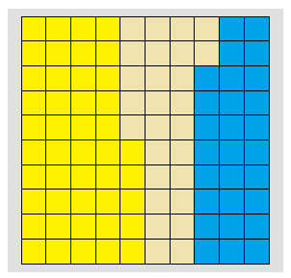
One hundred offices need to be painted. The workers choose between yellow, blue, or beige paint. They decide that $45\%$ of the offices will be painted yellow; $28\%$ will be painted blue, and the remaining offices will be painted beige. Create a model that shows the percent of offices that will be painted each color. Write the amounts as decimals and fractions.
Color | $$\%$$ | Fraction | Decimal
Yellow | $$45$$ | $$\frac{45}{100}$$ | $$0.45$$
Blue | $$28$$ | $$\frac{28}{100}$$ | $$0.28$$
Beige | $$27$$ | $$\frac{27}{100}$$ | $$0.27$$

Problem Set Sample Solutions

- Marissa just bought $100$ acres of land. She wants to grow apple, peach, and cherry trees on her land. Color the model to show how the acres could be distributed for each type of tree. Using your model, complete the table.
Tree | Percentage | Fraction | Decimal
Apple | $$26\%$$ | $$\frac{26}{100}$$ | $$0.26$$
Peach | $$45\%$$ | $$\frac{45}{100}$$ | $$0.45$$
Cherry | $$29\%$$ | $$\frac{29}{100}$$ | $$0.29$$

Apple–Yellow, Peach– Green, Cherry–Blue

- After renovations on Kim’s bedroom, only $30$ percent of one wall is left without any décor. Shade the grid below to represent the space that is left to decorate.
0.01 | 0.01 | 0.01 | 0.01 | 0.01 | 0.01 | 0.01 | 0.01 | 0.01 | 0.01
0.01 | 0.01 | 0.01 | 0.01 | 0.01 | 0.01 | 0.01 | 0.01 | 0.01 | 0.01
0.01 | 0.01 | 0.01 | 0.01 | 0.01 | 0.01 | 0.01 | 0.01 | 0.01 | 0.01
0.01 | 0.01 | 0.01 | 0.01 | 0.01 | 0.01 | 0.01 | 0.01 | 0.01 | 0.01
0.01 | 0.01 | 0.01 | 0.01 | 0.01 | 0.01 | 0.01 | 0.01 | 0.01 | 0.01
0.01 | 0.01 | 0.01 | 0.01 | 0.01 | 0.01 | 0.01 | 0.01 | 0.01 | 0.01
0.01 | 0.01 | 0.01 | 0.01 | 0.01 | 0.01 | 0.01 | 0.01 | 0.01 | 0.01
0.01 | 0.01 | 0.01 | 0.01 | 0.01 | 0.01 | 0.01 | 0.01 | 0.01 | 0.01
0.01 | 0.01 | 0.01 | 0.01 | 0.01 | 0.01 | 0.01 | 0.01 | 0.01 | 0.01
0.01 | 0.01 | 0.01 | 0.01 | 0.01 | 0.01 | 0.01 | 0.01 | 0.01 | 0.01

  - What does each block represent?
Each block represents $\frac{1}{100}$ of the total wall.
  - What percent of this wall has been decorated?
$30\%$

