Lesson 16: Relating Scale Drawings to Ratios and Rates

Problem Set

For Problems 1–3, identify if the scale drawing is a reduction or an enlargement of the actual picture.
- ___________________________
  - Actual Picture b. Scale Drawing
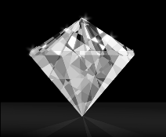
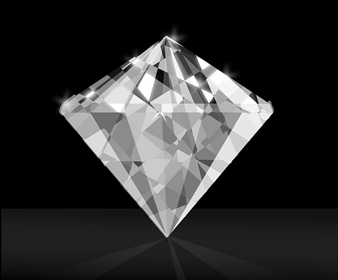

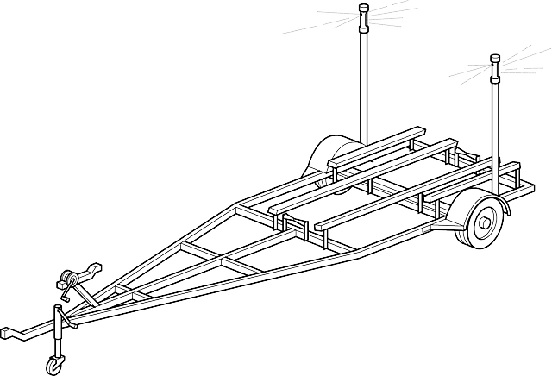
- ____________________________
- Actual Picture

- Scale Drawing

- __________________________
  - Actual Picture b. Scale Drawing
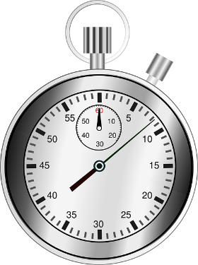
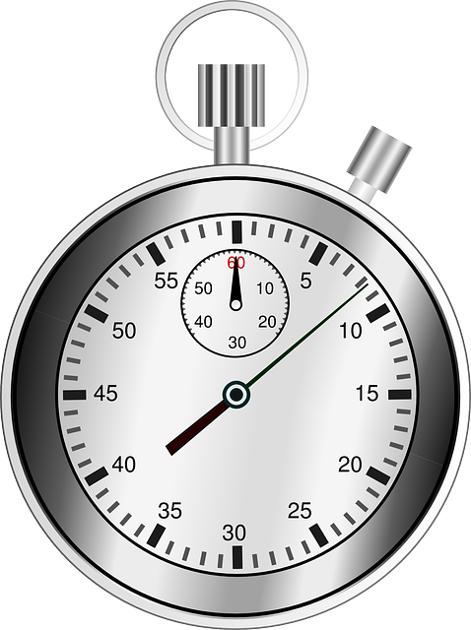

- Using the grid and the abstract picture of a face, answer the following questions:
 | $$A$$ | $$B$$ | $$C$$ | $$D$$
$$F$$
$G$
$$H$$
$$I$$

  - On the grid, where is the eye?
  - What is located in $DH$?
  - In what part of the square $BI$ is the chin located?

- Use the blank graph provided to plot the points and decide if the rectangular cakes are scale drawings of each other.
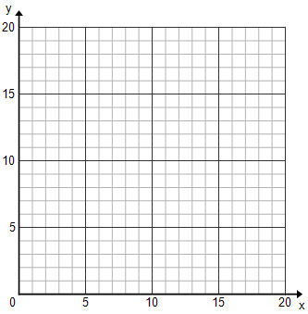
Cake 1: $(5,3)$,$(5,5)$,$(11,3)$, $(11, 5)$
Cake 2: $(1,6)$, $(1, 12)$,$(13,12)$, $(13, 6)$
How do you know?

