Lesson 15: Equations of Graphs of Proportional Relationships Involving Fractions

Problem Set

- Students are responsible for providing snacks and drinks for the Junior Beta Club Induction Reception. Susan and Myra were asked to provide the punch for the $100$ students and family members who will attend the event. The chart below will help Susan and Myra determine the proportion of cranberry juice to sparkling water needed to make the punch. Complete the chart, graph the data, and write the equation that models this proportional relationship.
Sparkling Water ($S$, in cups) | Cranberry Juice ($C$, in cups)
$$1$$ | $$\frac{4}{5}$$
$$5$$ | $$4$$
$$8$$
$$12$$ | $$9\frac{3}{5}$$
 | $$40$$
$$100$$

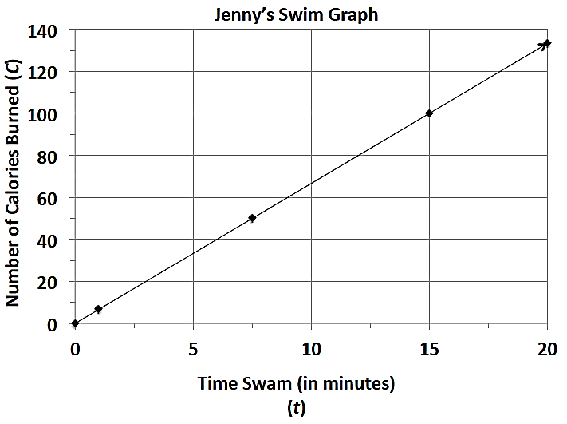
- Jenny is a member of a summer swim team.
  - Using the graph, determine how many calories she burns in one minute.
  - Use the graph to determine the equation that models the number of calories Jenny burns within a certain number of minutes.
  - How long will it take her to burn off a $480$-calorie smoothie that she had for breakfast?

- Students in a world geography class want to determine the distances between cities in Europe. The map gives all distances in kilometers. The students want to determine the number of miles between towns so that they can compare distances with a unit of measure with which they are already familiar. The graph below shows the relationship between a given number of kilometers and the corresponding number of miles.
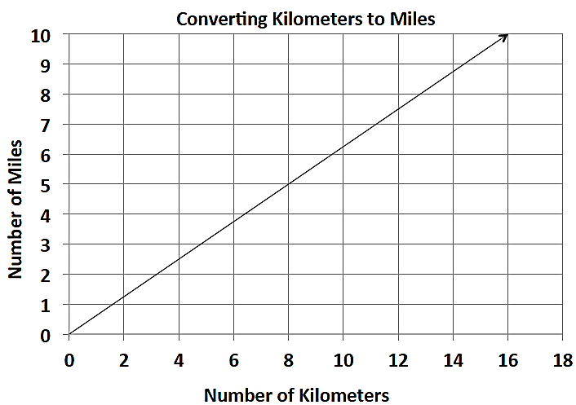

  - Find the constant of proportionality, or the rate of miles per kilometer, for this problem, and write the equation that models this relationship.
  - What is the distance in kilometers between towns that are $5$ miles apart?
  - Describe the steps you would take to determine the distance in miles between two towns that are $200$ kilometers apart?

- During summer vacation, Lydie spent time with her grandmother picking blackberries. They decided to make blackberry jam for their family. Her grandmother said that you must cook the berries until they become juice and then combine the juice with the other ingredients to make the jam.
  - Use the table below to determine the constant of proportionality of cups of juice to cups of blackberries.
Cups of Blackberries | Cups of Juice
$$0$$ | $$0$$
$$4$$ | $$1\frac{1}{3}$$
$$8$$ | $$2\frac{2}{3}$$
$$12$$
 | $$8$$
  - Write an equation that models the relationship between the number of cups of blackberries and the number of cups of juice.
  - How many cups of juice were made from $12$ cups of berries? How many cups of berries are needed to make $8$ cups of juice?

