Lesson 10: Interpreting Graphs of Proportional Relationships

Problem Set

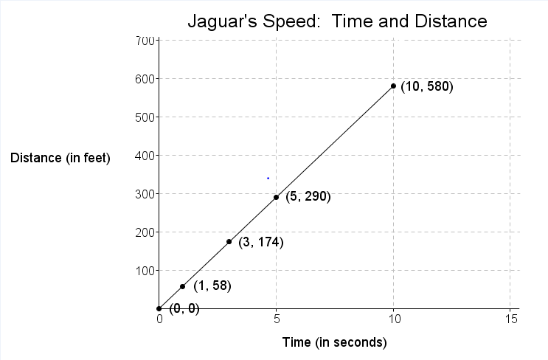
- The graph to the right shows the relationship of the amount of time (in seconds) to the distance (in feet) run by a jaguar.
  - What does the point $(5, 290)$ represent in the context of the situation?
  - What does the point $(3, 174)$ represent in the context of the situation?
  - Is the distance run by the jaguar proportional to the time? Explain why or why not.
  - Write an equation to represent the distance run by the jaguar. Explain or model your reasoning.

- Championship t-shirts sell for $\$22$ each.
  - What point(s) must be on the graph for the quantities to be proportional to each other?
  - What does the ordered pair $(5, 110)$ represent in the context of this problem?
  - How many t-shirts were sold if you spent a total of $\$88$?

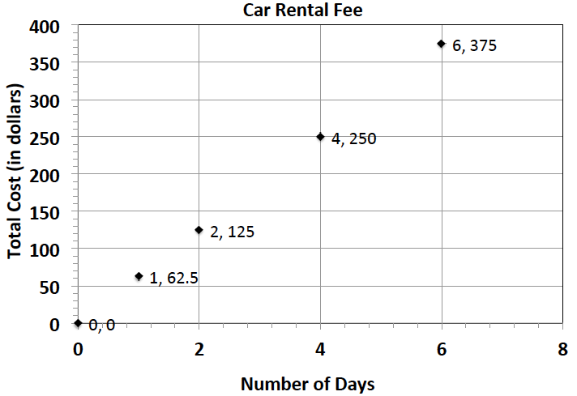
- The graph represents the total cost of renting a car. The cost of renting a car is a fixed amount each day, regardless of how many miles the car is driven.
  - What does the ordered pair $(4, 250)$ represent?
  - What would be the cost to rent the car for a week? Explain or model your reasoning.

- Jackie is making a snack mix for a party. She is using cashews and peanuts. The table below shows the relationship of the number of packages of cashews she needs to the number of cans of peanuts she needs to make the mix.
Packages of Cashews | Cans of Peanuts
$$0$$ | $$0$$
$$1$$ | $$2$$
$$2$$ | $$4$$
$$3$$ | $$6$$
$$4$$ | $$8$$
  - Write an equation to represent this relationship.
  - Describe the ordered pair $(12, 24)$ in the context of the problem.

- The following table shows the amount of candy and price paid.
Amount of Candy (in pounds) | $$2$$ | $$3$$ | $$5$$
Cost (in dollars) | $$5$$ | $$7.5$$ | $$12.5$$
  - Is the cost of the candy proportional to the amount of candy?
  - Write an equation to illustrate the relationship between the amount of candy and the cost.
  - Using the equation, predict how much it will cost for $12$ pounds of candy.
  - What is the maximum amount of candy you can buy with $\$60$?
  - Graph the relationship.

